Dear Brethren,
I will start by greeting you and your families and all the brethren at KSR. It is my sincere hope that the abundant love and kindness of God is always with you. In Zimbabwe, my family and all the brethren that I work with at Hillside and in the rural areas are doing well. No major issues to report on. May I take this opportunity to express our sincere condolences to Brother Gary and his family as they lost their dear Mom recently. When we heard about it, we prayed for your comfort. We hope you are being comforted by the hope we have in our Lord as we know that “This world is not our home” as a hymn we sing reminds us.
The following formed the core of my February work at Hillside and the rural areas:
Sunday 6 February
I concluded my study of the book of John which I started last year. This was a continuous study every Sunday when I am not travelling during Hillside Sunday bible study session before the service. I then preached from Romans 6. Amongst those present was Mark Wells, a British man and his wife who were visiting us for the second time. He is currently living in Zimbabwe. After my presentation, he approached me and wanted to have some talk with me. We then met on February 11. We studied together for about one hour fifteen minutes. His main aim that drove him to book an appointment with me was to tell me that I was teaching error if I teach that baptism is compulsory.
He strangely believes that baptism is optional and everyone should be told to decide whether they want to be baptised or not. To him baptism has nothing to do with salvation and therefore it is left to an individual to choose. I opened a couple of passages to show it was him in error not those who teach baptism as compulsory. I gave in when he blatantly said the Bible was full of error so he wanted me to close it and we use our wisdom to decide whether people should be baptised or not. From that day, he hasn’t visited Hillside again. I have talked with him on WhatsApp a few times, but looks like he is no longer interested. We shall see if he will ever come again.
Sunday 13 February
Nothando and I travelled to Mberengwa on Saturday 12 where we met Reason and Theresa his wife. We started the classes with Mberengwa brethren at 2pm and ended after 5pm. I was teaching from Ephesians 4 explaining especially what Paul referred to when he mentioned one body, one Spirit, one hope, one Lord, one faith, one Baptism, one God and Father of all. We had a very fruitful day.

Mberengwa office brethren who were present for the study.
Squatting wearing blue shirt and blue mask is Reason. Just under the window with veranda hat is his wife Theresa and immediately to her left wearing a navy blue dress is my wife Nothando.
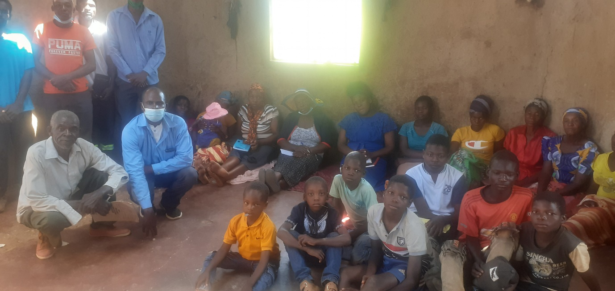
The following day on Sunday, Nothando and I met with Chitowa brethren. They had extended their meeting by an extra hour to accommodate the lessons they had asked me to teach. They normally begin at 10am and end 12am but on this Sunday they began at 9am and ended at 1pm. I had been asked to teach on how one becomes a Christian and how is he expected to live after he/she has become a Christian. I then asked them to allow me to teach a little from the Old Testament people of God before I could talk about the New Testament people of God. This is why they had to extend their time. The meeting was very encouraging. After the classes, we travelled back home
Chitowa brethren present after service.
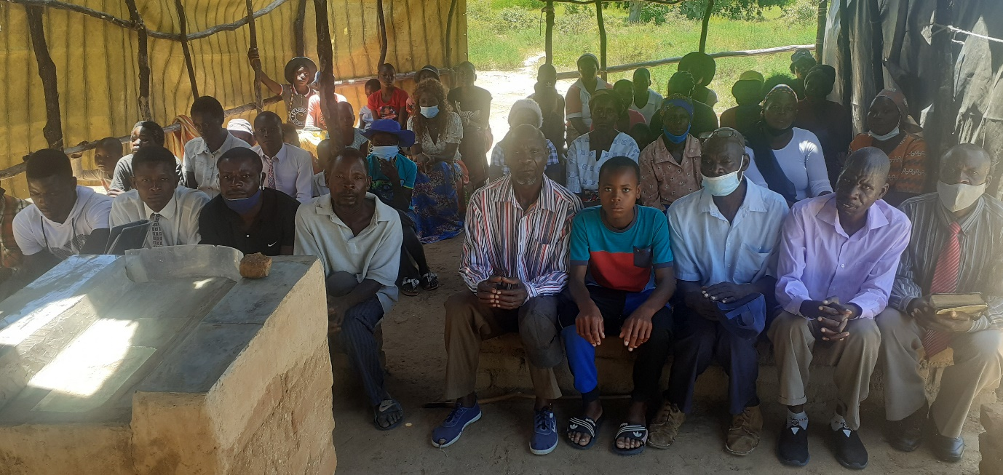
Sunday 20 and 27 February
I was back at Hillside and started a study from the book of Mathew. My sermons on the above dates were a follow up to my sermon on the 6th from Romans 6. In case there was someone who was a member at Hillside or who was visiting who had doubts about Baptism, I made a series of three lessons talking about Baptism from different verses and different angles. Theses three sermons are uploaded on You Tube titled “Buried therefore with him by baptism into death”, “One Baptism Ephesians 4” and “Baptism washing away sins”. As usual searching for my full name Professor Mashoko gives access to these and many other presentations uploaded there.
Lord willing, this coming weekend we travel to meet on Sunday with Chenhare, Bera and Ruware. More information on this visit in the next report.
Drought situation
In December when I sent through my relief distribution report, I stated that the food that we had distributed would approximately last until March which is this very new month we are in now. We were hoping thereafter to take a break from asking relief because the crops were doing very well as the rains were coming down throughout the country. Sadly, we are faced with a serious drought in most parts of the country. The rains have been gone for the whole of February and the crops are wilting very fast. It is a sad sight. The sky above is very blue and no sign of rains. Even if we receive the rains now, many crops are a write off. This is God’s doing and we trust in him. People had played their part by ploughing and planting, but God is God who does his things in his own way. We continue to rely on his providence.
Thank you for your continued support of the work in Zimbabwe. We pray the Lord may continue blessing you abundantly both spiritually and materially.
Professor

