Dear Brethren
Greetings to you and your families and all the saints that you oversee. I am sure they are all doing very well considering that just last night we had a good interaction on zoom presentation. What an interaction it was especially getting to see everyone that we were able to chat with. Due to time constraints, we did not chat to everyone even though we saw some brothers and sisters who participated in the presentation. This was historic for us. KSR brethren you are such a wonderful group to us. We thoroughly enjoyed every minute. Even though it was very late in the night, we did not even realise it. The following is a short report of my work in January.
Sunday 2, 8, 15 and 29 January 2022
On the above days, I worshipped at Hillside. I led the morning Bible study class from the book of Genesis that I had been teaching for a few months since mid last year. I have finished the book and I have started a study linked to the Bible periods but this one is more of a survey of the Bible. I am mainly focussing on the books and how those books contribute to the story of Christ. This will go on for a few months to come.
On the 2nd, I preached and my sermon was just a recap of 2022 encouraging brethren to use their achievements and even their failures they encountered while serving God to shape 2023 and beyond. On the 29th, I again preached. My sermon was from Exodus 5 particularly verse 2 in which Pharaoh asked Moses “Who is the Lord that I should obey him?”. This lesson is uploaded on You Tube with the same title. Searching for Professor Mashoko on You Tube gives access to this and other uploaded lessons.
Sunday 22 January 2023
On this day Nothando and I were travelling for the court case I have already told you about. We worshipped with a new and small congregation called Mutuvi roughly five kilometres south west of Bera. It is in the general area with Bera, Chenhare and Ruware. Marvellous Nyoni and three other members who have been members at Bera since 2019 decided to start this congregation. This was a good idea to try and reach out to the people whose homesteads are close to the local shopping centre which is a hive of activities and beyond. So far, they have baptised six people and they are meeting just behind the shopping centre. They have already invited me to teach in a two-day gospel meeting they are arranging to happen after April. We hope by then their Chief would have been convinced to allow the churches to meet. I see the area as very fertile if extensive teaching is done. We pray to God to allow us to work in this area and he may cause the increase if it is his will.

The following picture was taken on the day. Marvellous is standing second from the left and he preaches at the congregation. Four of the men standing and two of the ladies plus me (not in the picture) were visitors on our way to the court.

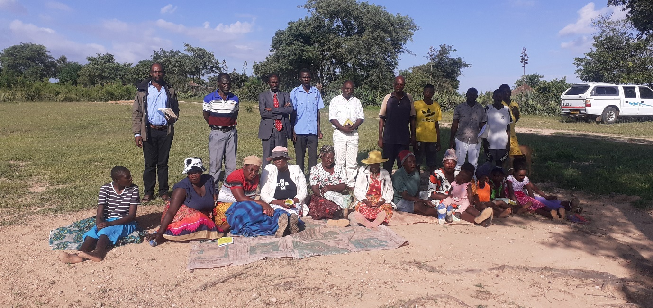

Natural disaster
On the 1st of January 2023, our dear sister at Hillside Prisca Dladla in her late 60s had her rural home in Tsholotsho over 150 kilometres west of Bulawayo set ablaze after being struck by lightning and was completely destroyed. She works as a domestic worker in Bulawayo and she earns small wages. She spent the festive holiday in the rural areas and the day she left back to Bulawayo, the home was struck. No one was injured but her household property and the structure were completely destroyed. She is due to retire in a year or two and the home was her retiring home. Now she is back to square one and definitely needs assistance to rebuild the home. Hillside congregation from their thin coffers set aside $400 to assist which is just a drop in an ocean. The following pictures show the destroyed home. The structure in the picture is no longer there. The Headman of the area ordered it completely destroyed after it was burnt and the bricks were thrown away as rubble. African customs are based on superstition. It is superstitiously believed that if a house is struck by lightning, the remnant has to be brought down so that the lightning will not strike again. This is just a custom not based on science, but the headman has power to enforce it in the rural areas.
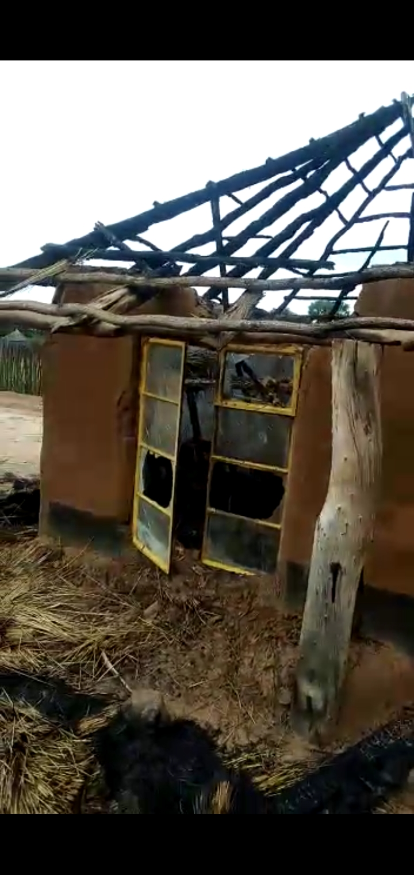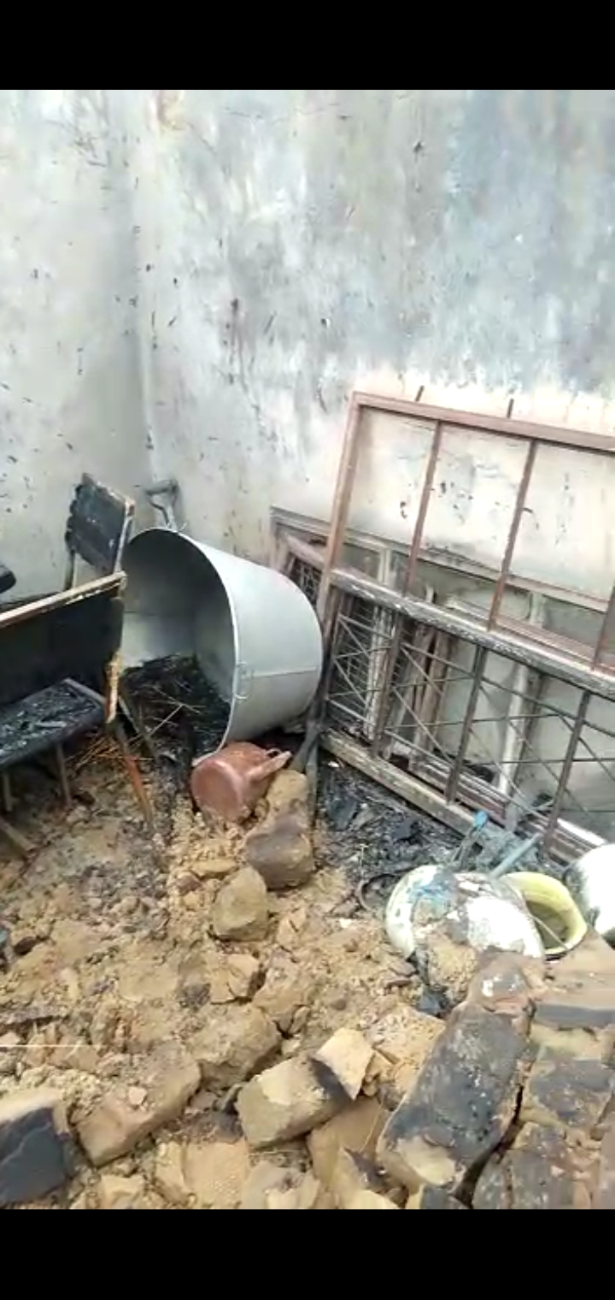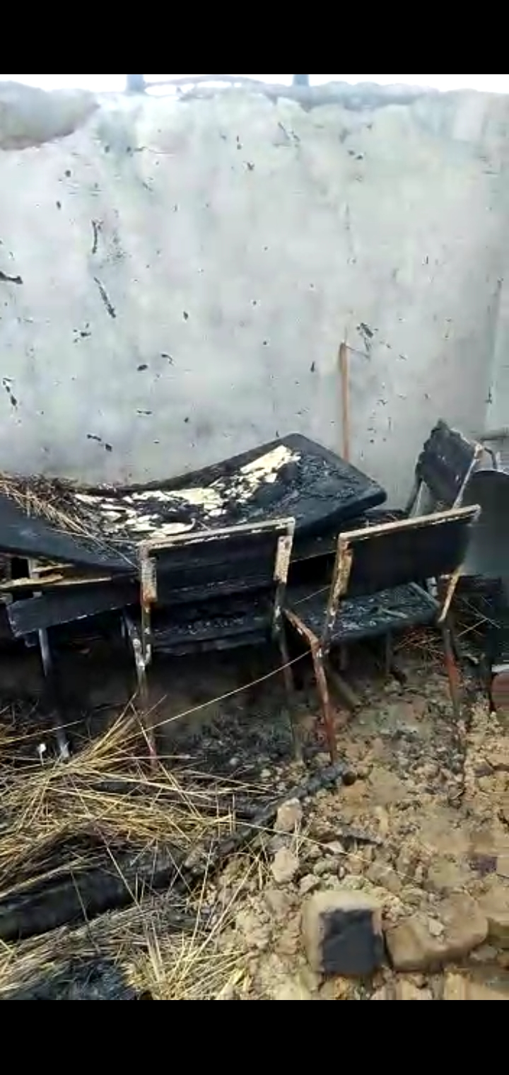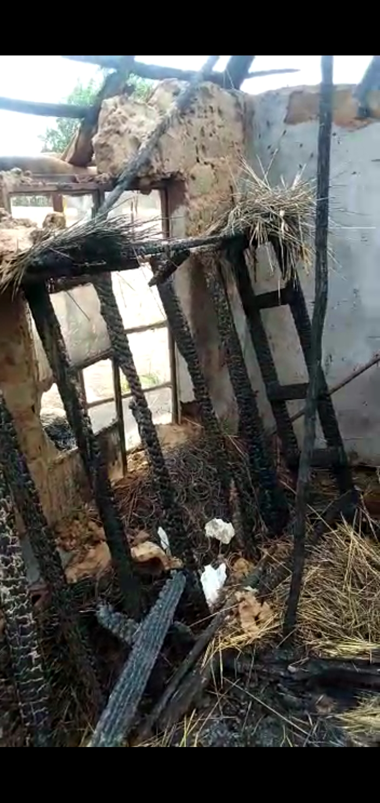
Drought Relief
In my November relief report, I mentioned that the next relief would be needed in early February. We were hoping that the relief might be the last for a while as we were hoping people would harvest from their fields. The rains have been sparse so far since the beginning of the rainy season in December. Some crops are showing moisture stress. We will be able to make an accurate conclusion perhaps in March. In the meantime, if KSR is able to help, we can distribute the relief next week. I am travelling on Thursday morning to meet with Bera, Chenhare, Mutuvi and Ruware brethren to have a post mortem of the judgement that was passed on John Makopa and Tichafa Munemo. We will come up with a strategy of how to distribute the relief while the chief of the area still insists the church should not congregate for either worship or relief distribution. I will give you the feedback on the Thursday meeting.

