Dear Brethren
I find a lot of joy to write this report that contains information of the work the Lord allowed me to do in April. It is my sincere hope that I find all of you doing well with your families and the KSR family. We are thankful the Lord has kept us safe thus far.
Sunday 2 April 2023
I concluded my two weeks stay in the Philippines on this day. Rodelio Baagin, the man who hosted me during my stay brought me on Saturday 1 April from La Union province around three hundred kilometres away from the capital city Manila to Cavite province which is closer to Manila. I spent that night at the house of a brother called Jun Samontina. On Sunday morning Jun took me to Sunshineville Church of Christ first where I taught in the Bible class before service. The following picture shows the brethren at Sunshineville.
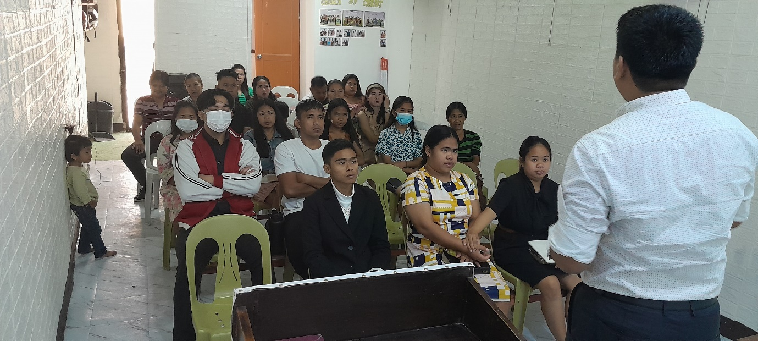
After service at Sunshineville, we went to visit a family that has a father, his daughter, and the son in law as Christians already. They moved from their usual residence where they were able to worship with Sunshineville. Where they now live is a distance away from the Church and they had not attended services for some time. I led a study in their home to encourage them to change their situation. It is commanded in the scriptures not to forsake the assembly. I proposed to them that since there is three adult Christians in this family, they could start meeting in their home and they might soon have one or two neighbours joining them. In the following picture wearing blue shirt is me stressing a point during the study with this family.
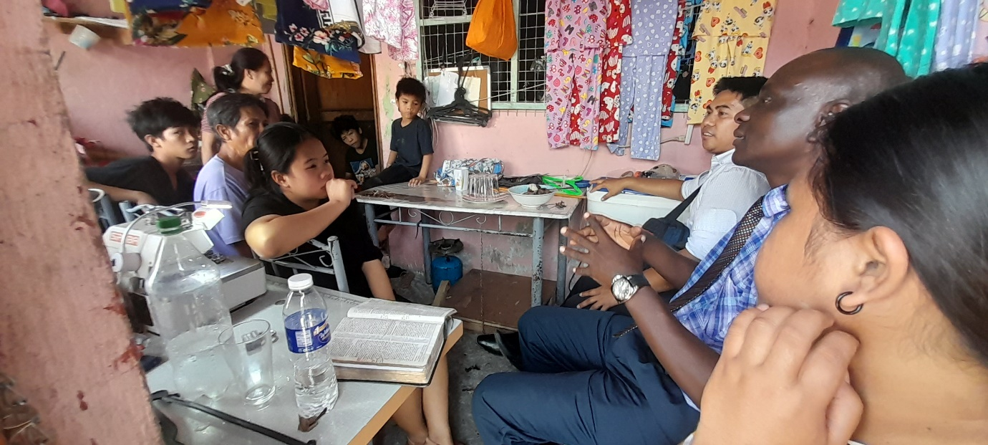
After lunch we went back to Jun’s home where there is a congregation which meets there. The congregation is called Bancal-Carmona Church of Christ. I got an opportunity to teach from PowerPoint. Immediately after service around 4pm, Jun drove me to the airport to catch my 9pm flight. I came back home and arrived safely the next day evening. The following picture shows the brethren at Bancal Carmona Church.
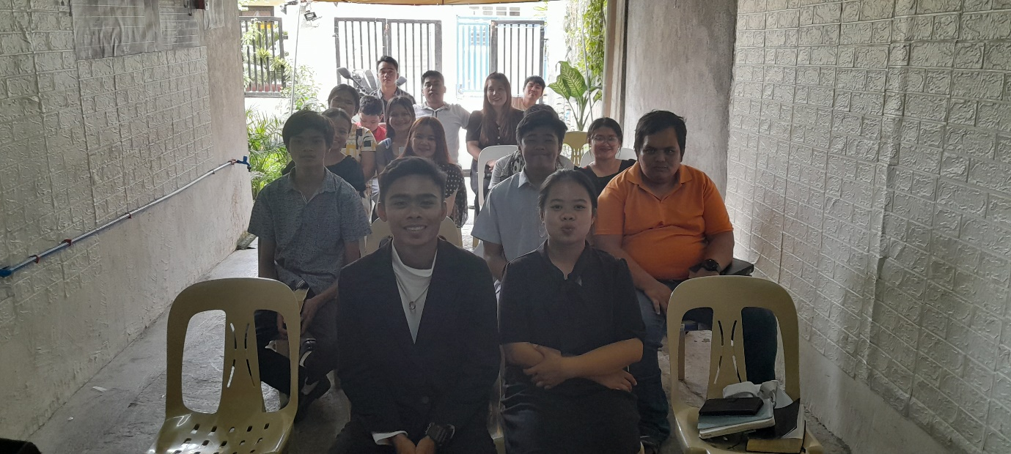

Friday 7 to Sunday 9 April
Having been home for three days, Nothando and I left Bulawayo to Kwekwe about 250 kilometres away. I had an invitation to teach throughout the entire Easter weekend. Jabulani Hingi is a man that KSR helped last year to have a hernia repair. He used to work in Hwange a town that is over 300 kilometres to the north west of Bulawayo. The company closed shop and he moved to Kwekwe where he now lives. His late father used to work for a big steel making company called Ziscosteel which again closed shop some years ago. When the company closed and retrenched all the workers, the workers were allowed to own the company houses they were occupying at the time of being retrenched. Jabulani’s father benefitted. So Jabulani, his wife and their four children live in this house. Him, his wife, their daughter, and a son are Christians. They have started meeting in their house. Their invitation was intended to have some of their neighbours hear the truth. I taught the whole Friday and Saturday. This was a lively class as I spent a lot of time answering their questions. Every class with lively people asking questions becomes very profitable.
The following two pictures show the people who attended the classes on both days. Sunday we met for worship with them and left thereafter to Bulawayo.
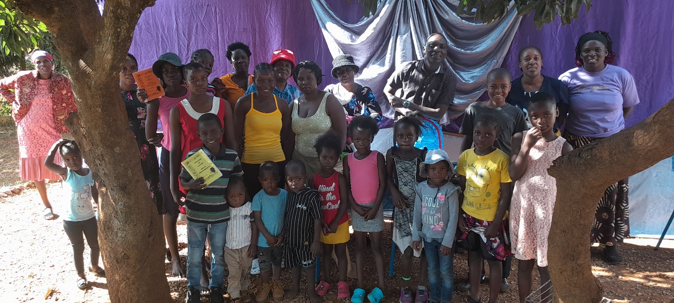
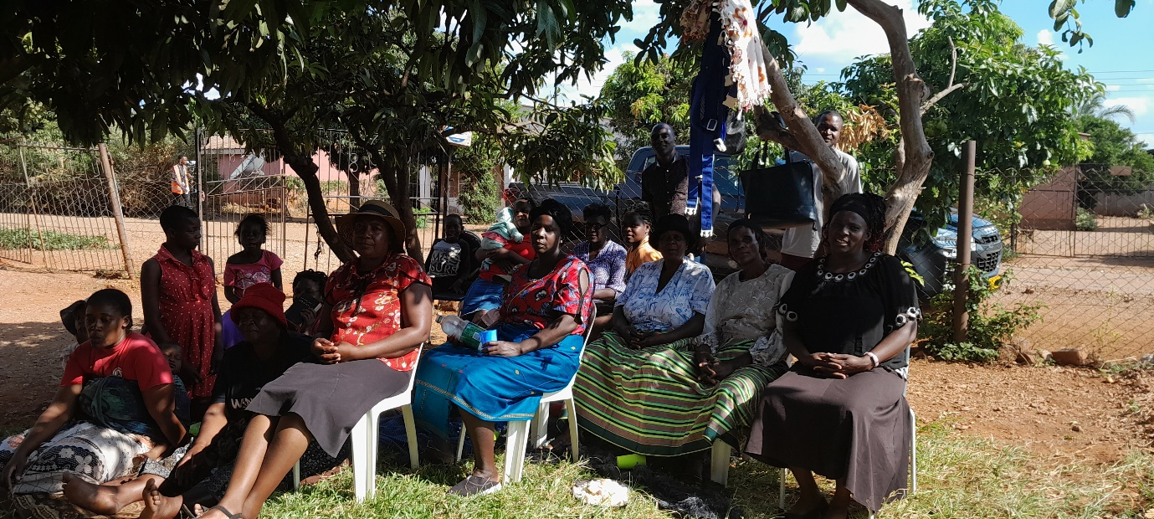

Monday 10 to Monday 17 April
I hosted thirteen youngsters for Bible Periods classes at our house in Bulawayo. The youngsters were drawn from different congregations. The following picture has the youngsters with my two sons Precedent and Praiseworthy taking part.
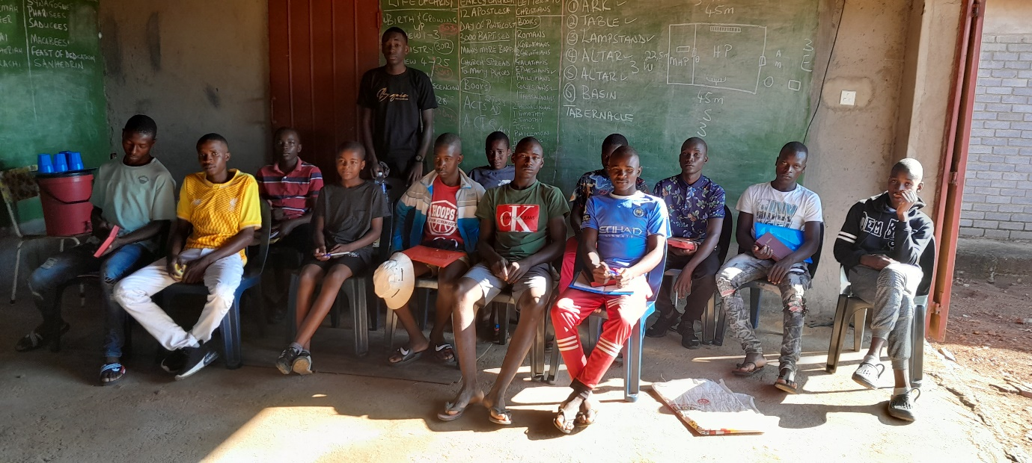

Monday 17 to Monday 24 April
The youngsters left in the morning of Monday 17 April and older men also drawn from different congregations arrived for the same classes. Brother Allen got two opportunities to teach on Zoom in both the two classes. He taught from the book of Judges. The following is the picture of the men during the class.
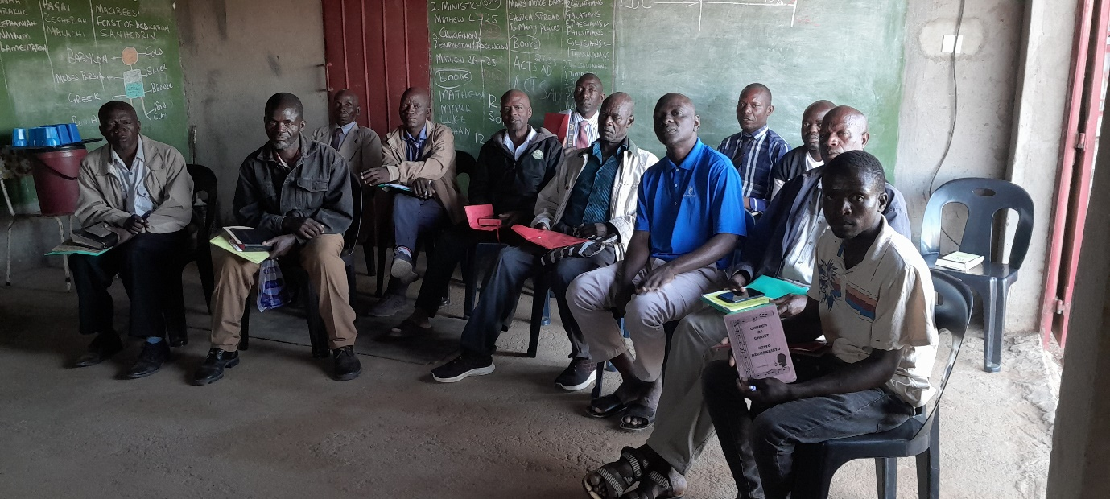

Wednesday 26 to Friday 28 April
The men left on Monday 24 April. I rested on Tuesday and on Wednesday Nothando and I were on the road to the rural areas 250 kilometres away. That Wednesday I went to meet with brethren from Bera, Ruware, Chenhare and Mutuvi who gathered at Ruware Church building. I was starting a simple overview study from the book of Genesis. We began the study at 9am and ended at 4pm. We covered the first 25 chapters. The aim of the study is to have brethren know the general principles of this book which has many things like creation, marriage, sin etc starting. The following picture shows these brethren inside the building.

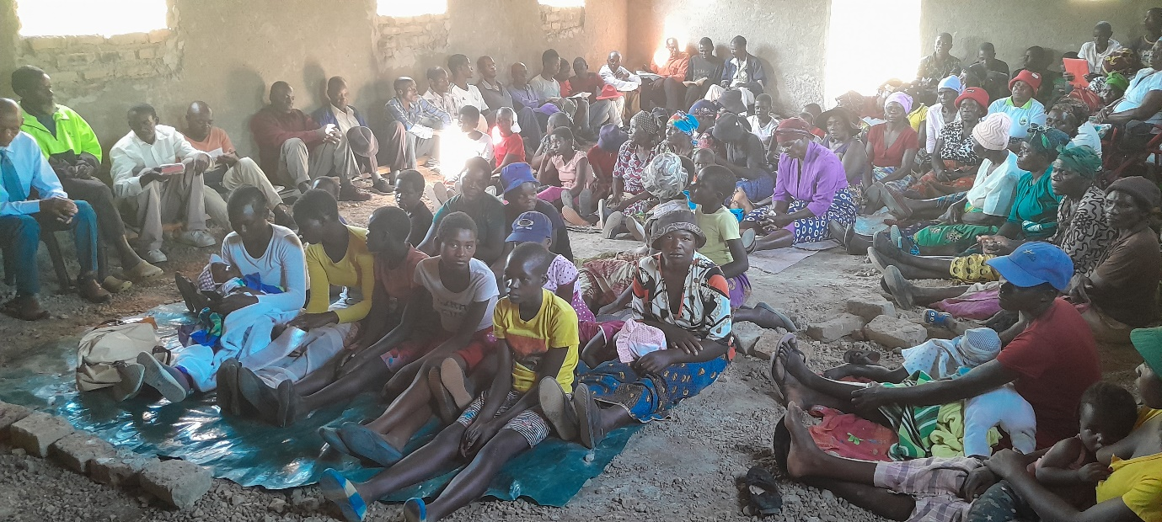

On Thursday I took the Genesis study to Masunda and the following are the brethren present on the day.

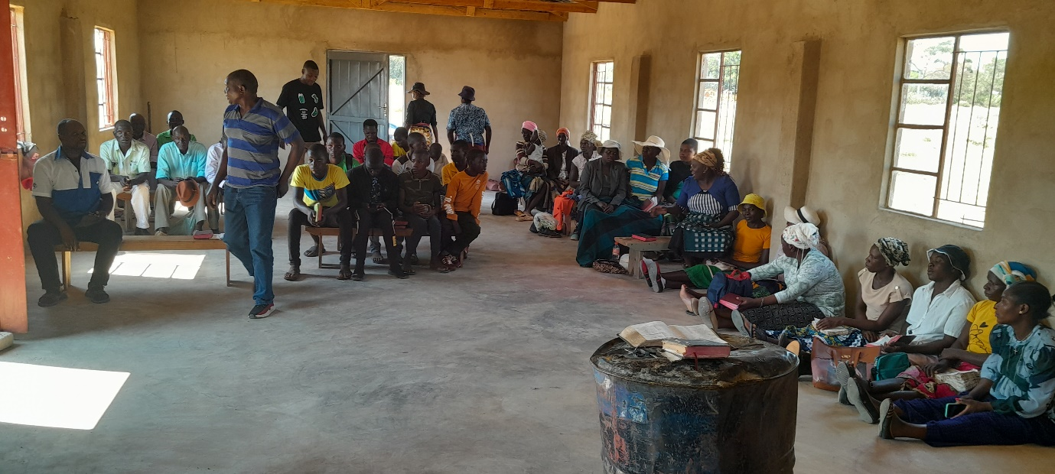

Lastly, on Friday I met with men and women of Chitowa at their building and I shared the Genesis study with them as shown in the following picture.
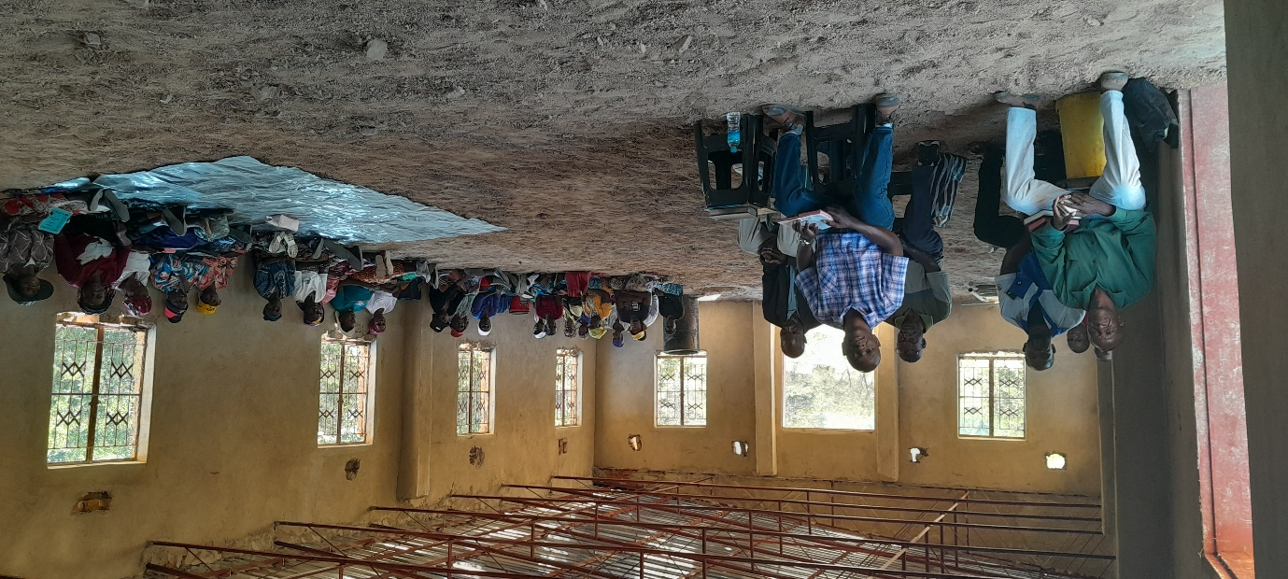
Saturday 29 to Sunday 30 April
Nothando and I were back again in Torwood, Kwekwe. We were coming from the rural areas and Ishmael from Masunda congregation the son of Reason Bwatikona accompanied us. We had the studies from around 10am to 2pm. Today Sunday we attended the service and thereafter we baptised two people. In the following picture Nothando is standing to the far right. The teenage girl dressed in blue who follows her and a woman with braided hair are the two who were baptised. I will go back sometime in May because the people we studied with showed very encouraging interest. I particularly enjoyed answering their questions.
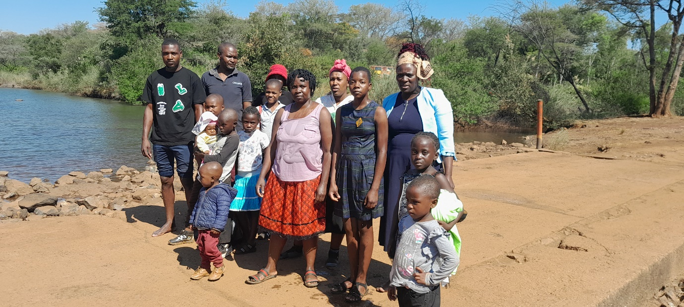
CONCLUSION
- Drought relief: Rural brethren have harvested their crops. The general outlook dictates that KSR may stop sending relief for a while as brethren have some food from their harvest. I will give you a new update around August after having done another assessment. When we resume, two congregations will be removed from the usual list. These are Chitowa and Masunda. Benjamin who is at Chitowa and Reason who is at Masunda are supported in their work by Capshaw Church in Alabama. I had a meeting with the two men on Friday 28 April and they indicated that they will get the relief supply from Capshaw. They wrote an email to the Elders at Capshaw asking for the relief which they hope to receive around August.
- The ban that had been imposed on four congregations namely Bera, Ruware, Chenhare and Mutuvi by the Chief of the area was lifted. However, the Chief demanded that only three congregations should remain in the jurisdiction of sub chief or headman Shiku. I will give you a little explanation for you to understand. The chief who had banned the gatherings is called Para Chief Masunda who oversees five headmen. Each headmen oversees many village heads while a village head oversees one village which has many households. In this case Headman Shiku oversees 45 village heads four of which are the villages where each of the four congregations meet. What the Para Chief is saying is that in those 45 villages covering a vast area of approximately 20x20 kilometres, he only allows three congregations of the Church of Christ. To him he believes only political formations can be many but Churches should be limited to a certain number.
- To avoid another protracted battle with this Chief who seems to be having a sinister agenda, Mutuvi brethren who were the newest decided to disband their group and they will be absorbed by the other three. Mutuvi had been strategically situated at the local shops to try and catch many people who visit the place. This newest requirement from this Chief means the gospel cannot expand in this area beyond where it has already been taught. Why he wants to stifle it, only he knows. Thank you for being supportive financially and with prayers during the ban.
Thank you
Your brother
Professor

