Dear KSR Elders,
Greetings to you from Zimbabwe. Hoping I find you doing well. Here we are thankful the Lord has kept us safe thus far. Allow me to present to you the following report which captures the highlights of how the relief funds you recently sent were spent;

I received the funds in full, a total of $6920 on Tuesday 28 February. We placed the mealie meal order from the supplier who supplied us in November 2022. He is based in Masvingo town 300 kilometers away from Bulawayo. He milled and had stocked up the required quantity by Friday 3 March. I then travelled to the rural areas yesterday Saturday to team up with Reason and Benjamin as usual in distributing the mealie meal. The total bags were 208x50kgs and 264x25kgs. The supplier ran out of 50kg empty bags after packaging 208 so the remainder which was 232 bags were packaged in 25kg bags. In terms of tonnage this gives a total of 12 tonnes.

The mealie has gone up to $25 per 50kg up from around $20 at the close of 2022. In total we paid $6k for the whole consignment minus transport. $920 then took care of my transport to and from Bulawayo and the hired delivery truck from Masvingo town to the beneficiaries and refreshments.

We delivered the mealie to Masunda brethren first as shown by the following picture.
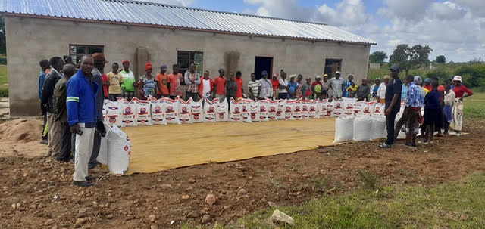

After Masunda we proceeded to Chitowa as shown by the following picture
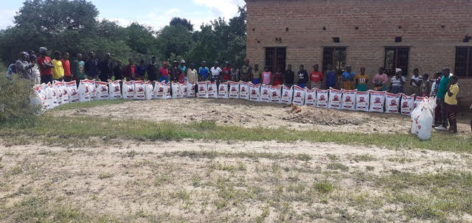

We then proceeded to meet the brethren from Bera, Ruware, Chenhare and Mutuvi. These brethren walked some distance from their usual receiving points to a common place across the river away from the jurisdiction of the Chief who banned the Church gatherings and has not yet lifted the ban. The river is the boundary of his area and another Chief. We wanted to avoid further confrontations with this Chief while we are still waiting for him to lift the irrational ban. The Chief and his team claim there are a few technicalities they are dealing with before they can conclude the case and allow the churches to meet. We still wait patiently and give them a few more weeks before we can take any necessary steps available to us to have him reverse his ban. In the meantime, brethren are meeting in their homes every Sunday.

At this common ground across the river we distributed the mealie meal to the brethren from these four churches. We did not have time to separate them by congregation. Instead, they just stood as a big group behind their mealie meal for the purpose of the pictures. The hired delivery truck can be seen in the background.
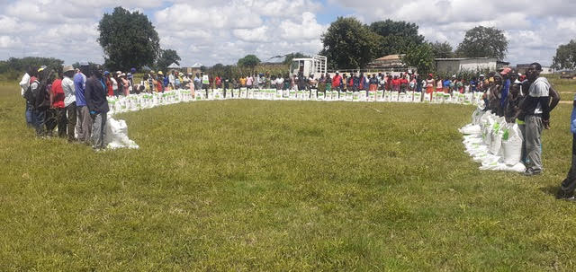

All the 25kg bags went to this group and each person would get 2 bags. The following is the breakdown
50x50kg bags to Masunda
48x50kg bags to Chitowa
25x50kg bags to Ruware
69x50kg bags to Chenhare
33x50kg bags to Bera
15x50kg bags to Mutuvi

TOTAL NUMBER OF BAGS = 240

The following is the tax invoice confirming the quantity and price of the mealie meal.
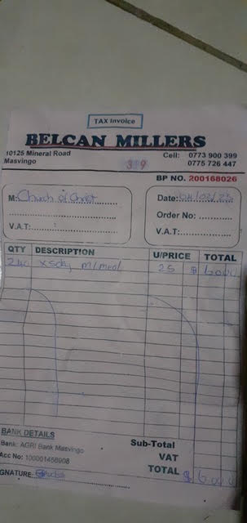
After delivering the mealie meal to all the brethren, I left Reason and Benjamin at Mhandamabwe shopping centre and I came back to Bulawayo.

Thank you brethren for standing with us during needy times. The rural brethren asked me to convey their gratitudes. We await to see what amount of food will be harvested from the fields which should be by end of April. I will continue giving you updates.

Thank you

Your brother
Professor

