Puerto Rico Work Report (March 2022)
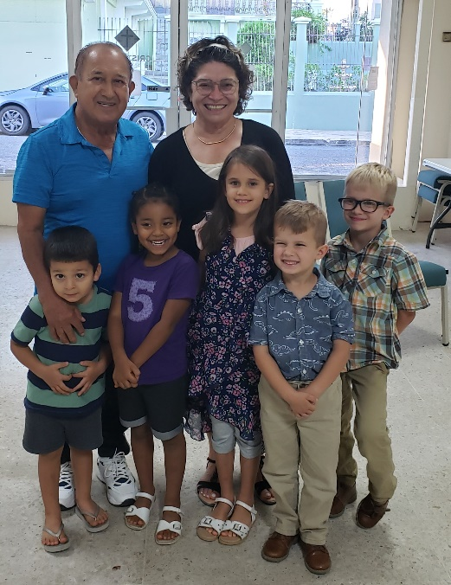
Caleb Westbrook – HC 9 Box 91738, San Sebastian, PR 00685
713-304-9770/ westbrookcaleb@gmail.com

Greetings Brethren in our Lord Jesus Christ

The Lord continues to bless us with open doors, and we have been very busy this past month. It seems like the work has a multiplicative effect. Bible studies open up to other studies. We give thanks to God for the abundance of work even though it can feel a bit overwhelming at times. We have been preparing for my family’s upcoming move to Arecibo which should happen over the course of the middle to end of April, Lordwilling. I was very optimistic in my estimations of how little work I thought the move would be since we are only moving an hour away. I thought, “It can’t be as bad as the last move when we were moving thousands of miles from the US to PR.” Kaitlin tried to temper my wildly inaccurate expectations, and as the move gets closer, I am beginning to see more and more just how much logistical work this will really be for me and my family. Nevertheless, we are excited about the opportunity, and we cannot wait to get started with some of the projects we have planned for personal work in the Arecibo area. We would greatly appreciate your prayers on our behalf as we finish preparing and go through this transition. The next month ahead will surely be quite exciting.

Studies Abound in Arecibo
Over the past month, I have spent a lot of time in Arecibo. Normally Wednesdays through Fridays are filled with Bible studies in the Arecibo area. Brother Edwin has continued to do a wonderful job helping me set up studies in Arecibo. Edwin is such a dedicated worker, and he really excels with personal work. He is very excited about our upcoming move to Arecibo and has plans to add even more studies after the move. Edwin and I have had a lot of time to continue our personal studies together on biblical authority and hermeneutics. There have been seemingly innumerable opportunities with Edwin that simply arise from working together with him on a regular basis. Many of the people that we have visited have either set up ongoing studies with us and/or have started visiting worship services with the church in Arecibo. Edwin is very encouraged and definitely sees the power of individual and personal evangelism. Many of these experiences have also had a significant impact on discussions of institutionalism, some of which I will mention later.

In my last report, I mentioned studies with Ramon and Maribel, who are newer Christians and were just recently married last month. Edwin and I have had the opportunity to visit with them and encourage them to start establishing practices of godly discipline with their family. There are many challenges for this young couple and sadly they do not have many godly examples within their physical families. They are often tempted to follow the path of customs, culture, and habits they already know. Edwin and I have been investing heavily in trying to establish a foundation of biblical knowledge and conviction with them. Yet, even as active as we are, Satan does not cease to attack this young couple. Kaitlin and I are hoping that after the move we can spend more time with them one on one and try to offer some marriage studies with them and other members of the congregation.

Edwin and I have continued our studies with Yadimar and all the contacts that she sets us up with. For some time, we have studied with Marilee, one of Yadimar’s friends. Marilee has participated in several studies with us, but still has not yet decided to become a Christian. This past month she had suffered a lot of challenges with her two sons who were in serious problems with the police. One of her sons, Gabriel, is now currently under house arrest and went through some very scary situations over the past month. We were able to help encourage Marilee through these challenges and were also able to set up bible studies with her and her son Gabriel on a weekly basis. It is very interesting to see how Gabriel is reacting to the bible studies. Even though he is only 20 years old, he has had a very rough life so far and when we speak to him about the consequences of sin it really seems to resonate with him on a real and personal level. At the end of March, he was able to receive permission to attend services with us at Arecibo. Gabriel faces many challenges, but Edwin and I are very thankful for his current interest in studying with us.

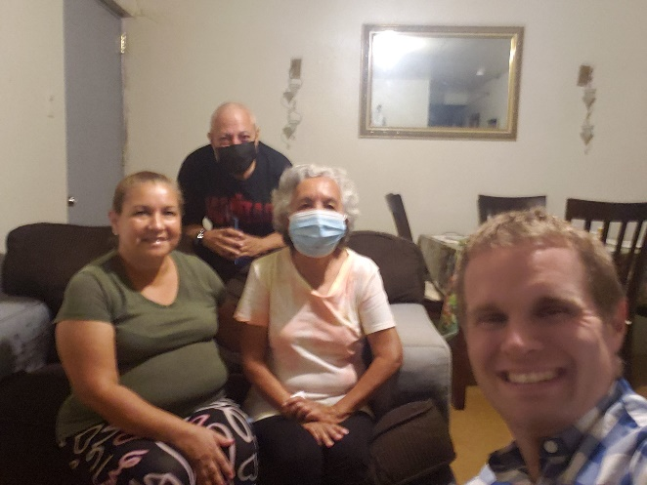
This past month Edwin and I were able to re-establish contact with some sisters who had been out of touch since the beginning of the pandemic. Mara, and her mother Alicia, live close to the building in Arecibo but had not been attending for some time. Alicia had some issues with one of the members at Arecibo, so we encouraged her to resolve the problem and return to services. Thankfully, the issue was resolved and both she and her daughter started attending Arecibo again. Mara is baptized but has spent a lot of time with Pentecostal influences in her life. Even though she has a basic understanding of the Bible there are a lot of misconceptions and some outright errors in her thinking. I have been trying to emphasize going back to the Biblical text and reading the Scriptures directly. This has been a particular challenge because Mara is barely literate, and Alicia does not know how to read. This is not my first time teaching in contexts like these, but it does raise some unique situations. For example, last month Mara claimed that Jesus baptized Cain and Abel in the book of Genesis. When Edwin and I tried to patiently tell her that was not correct, she challenged us saying, “Well, if you would read the book of Genesis then you would see it.” Both Edwin and I opened our Bibles and gently challenged her to show us where in the text that was written. After Edwin and I started reading out of Genesis, it quickly became evident that Mara had not actually read the book of Genesis, rather she was recounting what she had been told about Genesis. She was open to listening to the text and has had continued studies with us. We hope that there will be growth for both her and her mother.

There have been many other visits that Edwin and I have had over the past month. But two in particular that are worth noting are with Alvaro Andres and Yan. These are young men at Arecibo whom I have mentioned before in previous reports that continue to have studies with me. Both young men are going through a lot of changes in their lives, and I have been trying to encourage them and ground them in biblical wisdom. Alvaro Andres has shown a lot of growth, but sadly he does not seem as interested in learning about teaching and preaching as he previously had. Even though he has attended church his whole life, there are a lot of doctrines that he knows very little about. So, we have been examining topics like “Why we do what we do?” and biblical authority. Alvaro Andres seems sincerely interested in these studies and I hope they continue. Yan, on the other hand, has his plate full with college and work. We have spent a lot of time talking about priorities and biblical wisdom. Yan has some challenging family situations, but he is open to bible study and truly seems to have a receptive heart. Edwin has joined some of my studies with these young men and I am hoping the studies will continue to progress.

The studies and work are abounding in Arecibo, but as the move draws nearer, I have tried my best to communicate the upcoming hiatus I will be taking for the move. I am hoping to continue all the current studies with non-Christians, but for the studies with Christians, I have requested a hold until the beginning of May. There are many projects that await us in the future, Lordwilling, but the move needs to come first, and I need to be dedicated to helping my family with that transition for a time. Kaitlin and I have recently decided not to take a trip to the U.S. to visit family this year. With the move and the work, we have thought it best to forgo the U.S. trip this year. The brethren in Arecibo have been very helpful and supportive of our move and I have full confidence that Edwin will continue to keep things going even though I will be a bit occupied with the move for a week or two.

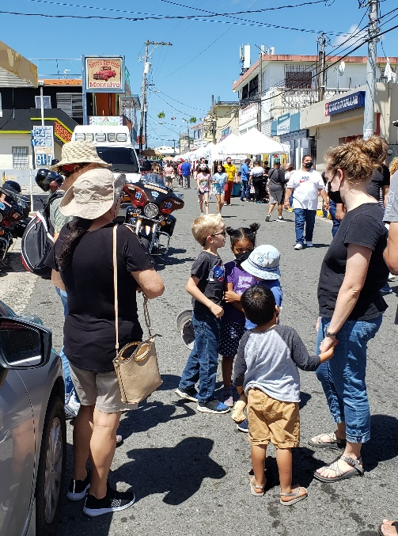
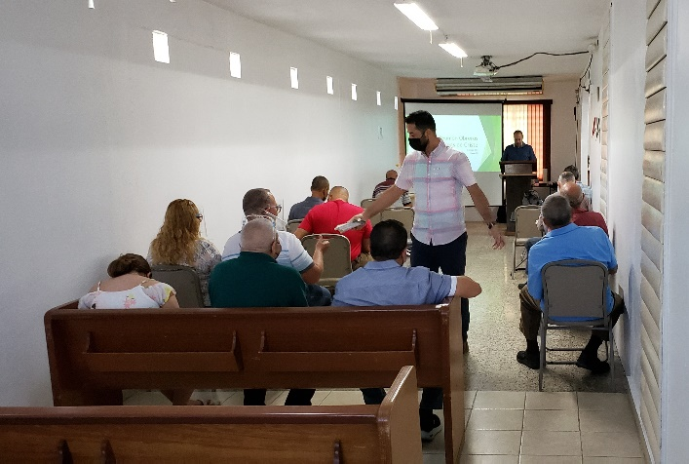
I would like to mention a study that I had the opportunity to attend this past month in Ponce. Every other month there is a meeting and study of the “Workers of the Church of Christ in Puerto Rico.” I mostly attend these meetings to stay in touch with brethren across the island and to help get a pulse on what is going on. Sadly, there are elements of this meeting that are very institutional. The brethren often talk about their efforts to pool money together to support a shared campground and they also talk about pooling money for other projects as well. At past meetings, I have publicly voiced my opposition to these practices, and I continue to engage with these brethren and challenge these questions on grounds of biblical authority. During this past meeting, I was particularly proud of brother Edwin from Arecibo. When the brethren were talking about the campground and their perceived need for funding it to evangelize to young people, Edwin got up and asked, “Brethren, why are you going to spend all this money on a campground when you do not have any young people to take to the campground? Why not spend our efforts evangelizing young people instead of building something that will not bring young people to Christ by itself? What good will it do to build a campground and invite young people afterward, when we aren’t even inviting young people to Christ and His church now?” I wanted to stand up and applaud. I didn’t, but I did give a hearty “Amen.” But even though Edwin didn’t argue against this erroneous practice the same way I would, it was evident that Edwin is starting to see the errors of institutionalized proxies. Institutional brethren often want to build something or start an organization to help meet a need, when in reality the Bible directs us to individual action and responsibility. I am thankful that Edwin is seeing the contrast in the work that he and I are doing together as opposed to the grandiose hollow plans of many institutional brethren in PR. There is still a lot of work to do on these fronts and it will take a long time, no doubt. However, I am thankful for the small steps of progress that we seem to be making in these areas.

The work in San Sebastian
The work continues to go well in San Sebastian. After my bible study on biblical authority, Eric started teaching on 2 Samuel. I have picked up the sermons for the past month and have been able to present some exhortations directed at some of the challenges for the members in San Seb. This past month we were able to spend more time with sister Elba and we were able to attend a festival in the county south of San Sebastian, called Las Marias. The event was called the “Festival de la China Dulce” (the Sweet Orange Festival). The Huggins family also had the opportunity to go, and we passed out a few bible tracts and invitations while we were there.

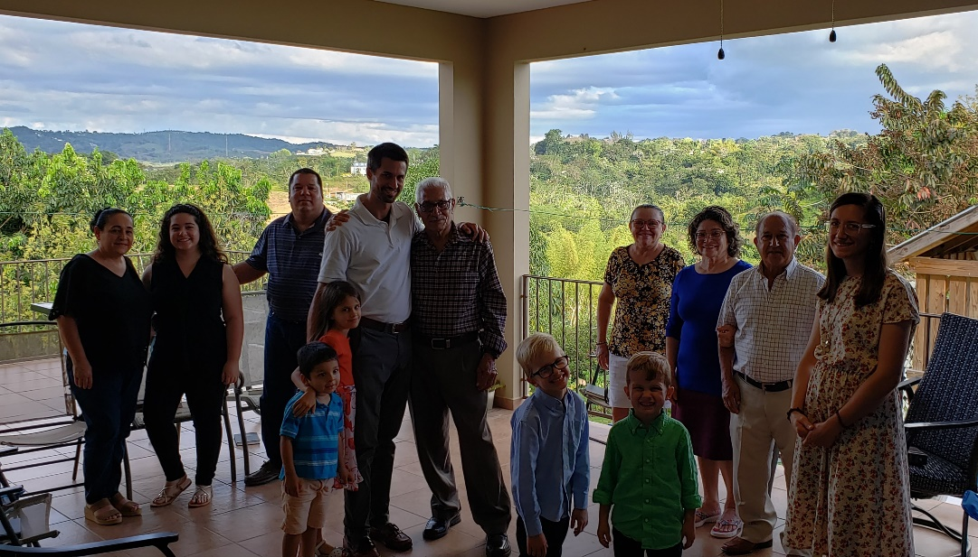
Last month there were some challenges with the water and electricity at our building. One particular Sunday we arrived and there was no water or light. So, we decided to meet at our house. Meeting on our back patio brought back many memories of times after hurricane Maria and also after the start of the pandemic. It made both Kaitlin and I reflect on the blessings of the past nearly 5 years that we have spent with the group here in San Sebastian. We are thankful to God for this house in San Sebastian and for the opportunity to use it in the service of the Kingdom.

In the middle of March, Eric Huggins announced that he and his family will be moving back to the United States. Eric has accepted a teaching position in Indiana, and they will be planning on moving in June. We are thankful for the help of the Huggins family over the past two and a half years. Their work and participation here were particularly helpful for my family and me. We hope that God will bless them in their move to Indiana and that their work in the Kingdom there will prosper to the glory of God! Until then, Eric will continue in his work here in San Sebastian and we will continue to strive to build up the body of Christ in this area.

Thank you again brethren for your faithful support, prayers, and fellowship in our work here in Puerto Rico. The work in the Kingdom is not a sprint, but rather a long marathon of a race. Yet, we do not grow weary in the work that God has provided for us, but we give thanks to Him who blesses us with abundance in so many areas. Please pray for us and the work here in PR! We are also currently going through a rather nasty power blackout here in Puerto Rico. We have been without power for the past few days. We would appreciate your prayers on this matter as well. If you have any questions about my work, please feel free to contact me at any time. May our great God of blessings always protect and keep you in His loving care!

Grace be with you always,
Caleb B. Westbrook

