Puerto Rico Work Report (May-June 2022)
Caleb Westbrook – HC 2 Box 47421, Sabana Hoyos, PR 00688
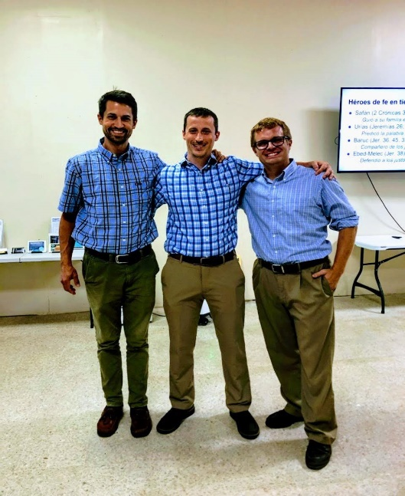
713-304-9770/ westbrookcaleb@gmail.com

Greetings Brethren in Christ,

My heart is so full from the tremendous blessings and work that God has granted us. The past few months have been exhausting, but so productive. We are now fully moved to Arecibo and are adjusting well to life up here on the north coast. This past month we not only finished the move, but also renovated our old house in San Sebastian and sold it. We have already closed on the house in San Sebastian which has brought closure to that tremendous chapter of our lives. I give thanks to God for the time that we spent in San Sebastian. We survived and overcame hurricanes, blackouts, earthquakes, the pandemic, political upheaval, and even problems in the church throughout our time in the San Sebastian house. It was an emotional transition leaving San Seb, but we trust in God who has given us open doors to continue our work in Puerto Rico. To Him be all glory and honor!
At the gospel meeting in San Seb, with Eric & Brigham

This past month also marked a significant change with the move of the Huggins family back to the states. The Huggins arrived in December 2019 and worked with us during difficult times of the pandemic. They spent 2 ½ years in San Sebastian with us and we are thankful for the work they accomplished together with us and the church in San Sebastian. We are sad to see them leave but hope and pray that they will find open doors for the work in God’s kingdom in Indiana. It was bittersweet to help them pack up, but we are confident that God will help them in their goals and that He will continue to help the work here in Puerto Rico.

Gospel Meeting Effort
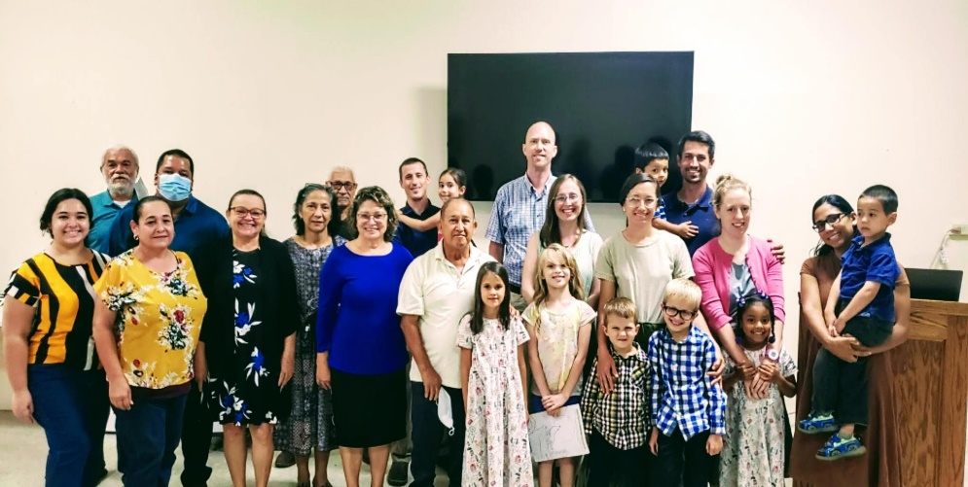
At the end of May, we were blessed to have Brigham Eubanks and his family come to work with us for two weeks. Brigham lives in the Atlanta, GA area and speaks excellent Spanish, and is a very sound Bible teacher. They spent their first week in San Sebastian with the Huggins and Brigham preached a gospel meeting for the group in San Sebastian on the book of Philippians. We had solid attendance for the meeting and the brethren were encouraged greatly.
Brethren at the gospel meeting in San Sebastian

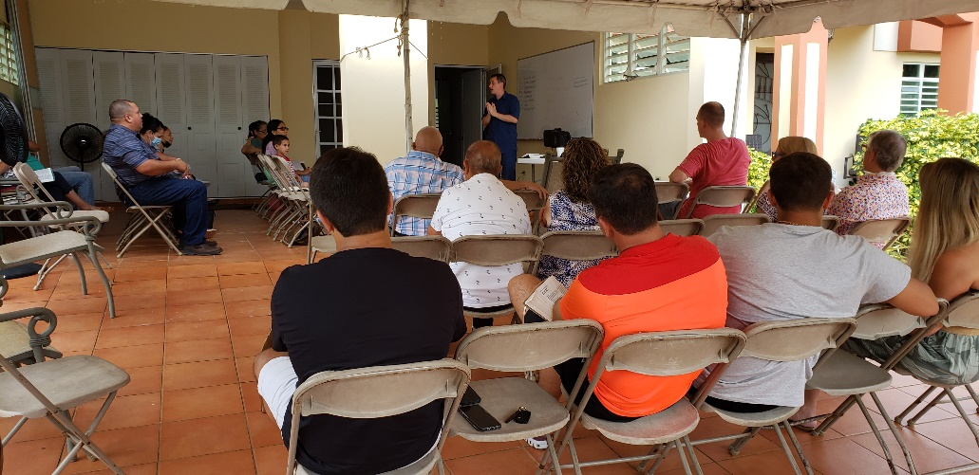
After the week in San Sebastian, the Eubanks family came up to Arecibo to stay with us for their final week here. We really enjoyed spending time with them and were greatly encouraged and reinvigorated by our studies and conversations together. Brigham accompanied me on several studies with Christians and non-Christians in the Arecibo area. Brigham’s wife, Esther, and mother-in-law, Lydia, helped Kaitlin with some of the ladies’ classes with the sisters from Arecibo. As if a recent move, gospel meeting, and hosting our visitors were not enough work, I convinced my wonderfully patient and hard-working wife to host an all-afternoon bible study at our house. At the beginning of June, we invited Brigham to teach an intensive 4-hour study on the book of Philippians at our new house in Arecibo. It was the first time that we had hosted or even seen such a study during our time here in Puerto Rico. We invited brethren from San Juan, Arecibo, and San Sebastian. We started with a lunch that Kaitlin and the sisters prepared, then we went into the Bible studies till later that afternoon, then afterward we shared a large dinner together. Kaitlin, Esther, and Lydia worked so hard helping prepare everything, and brother Brigham did an excellent job with the Bible classes on Philippians. We had around 40 people in total at our house, including 5 non-Christians who showed up for the studies. It was a wonderfully encouraging event and it was a great way to kick off the inauguration of our new house to welcome everyone to come together to study God’s word.
Brigham teaching at the study at our house in Arecibo

Work in Arecibo
The work in Arecibo has really been picking up. I have been working very closely with brother Edwin and we have been able to organize more bible studies together. The number of studies that we are having is tremendous. We have continued many of our normal studies with sister Yadimar and she has been so encouraging in her work to invite others to hear the gospel. Although there was a bit of a recess in our studies with Ramon and Maribel, we have now returned to study with them on a regular basis. Ramon comes from a Pentecostal background, and he is now starting to pay more attention to the differences between the practices of Pentecostalism in contrast to what the Bible says. There are many more smaller studies that Edwin and I have had over the past month, and I am so thankful for Edwin. He has an open heart and has been very encouraging to work with.

The most memorable study this past month was with Erick & Diana. They have only been Christians for about a year and are an older couple that lives west of Arecibo in Camuy. Up until this month, I haven’t had the opportunity to study with them directly. I had some concerns about details I had heard regarding their marital situation. So, I suggested we study the sermon on the mount (Matthew 5-7) together, knowing full well we would naturally hit some of the topics that they needed to discuss. When we arrived at Matthew 5:31-32 I was expecting to hear counterarguments about how the law of Christ did not apply to them when they were non-Christians. That doctrine, known among our brethren as the Hailey-Fuqua position is sadly the default belief for most Christians here in Puerto Rico. Puerto Rico was evangelized years ago by men who held the view that God’s law on marriage only applies to Christians, so without study or scrutiny, most Puerto Ricans have passively adopted that view. I was pleasantly surprised when both Erick & Diana, and Edwin agreed with what the Scripture said and accepted it without any pushback. Erick told me that he understands that they don’t have a right to be married and are willing to separate. We are going to continue to study the topic of marriage and divorce together. I pray that they have the strength and resolve to trust in God to follow through with this repentance. But in the 15 years I have been preaching and with the dozens of similar situations I have encountered, Erick & Diana have been the most open and willing to consider and follow the Truth that I have met. I give thanks to God for them and for the studies that we are having together.
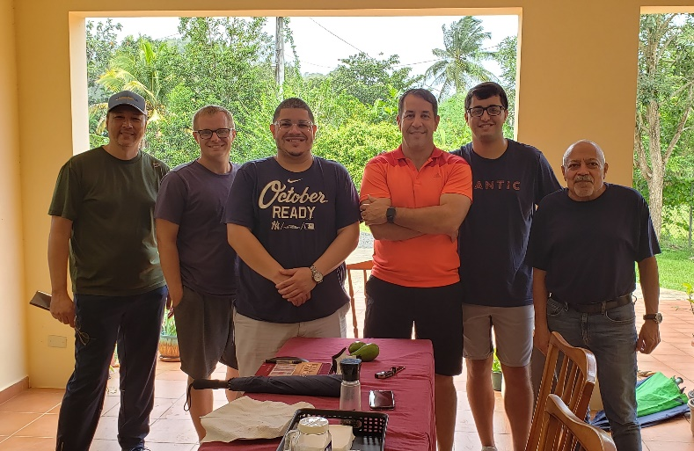
Another issue I have tackled this last month is the common practice here of taking the Lord’s supper individually at home outside of the assembly. This is a common practice here, especially since the pandemic, and the brethren have just assumed that it was the right thing to do. I have studied with two of the members here in Arecibo directly on this matter and have shown that the pattern we find in scripture is that the Lord’s supper is taken in the assembly of the saints on the first day of the week. I am grateful that the brethren have been open, humble, and honest in their consideration of the biblical pattern and have shown signs of understanding and repentance on this issue.

Recently Kaitlin and I had the opportunity to invite the men from the congregation at Arecibo over to our house to discuss membership and any doubts that they may have regarding our teaching. It was a productive meeting, and we were able to honestly discuss some of our issues that we had. There are obviously many significant problems we still have with some of the practices in the Arecibo church, but we believe that these matters are done out of ignorance and not maliciously. When we have discussed matters with the brethren here, they have always been respectful, open, and contemplative. There is a lot of teaching that needs to be done, but we are striving to show them patience as God has shown us patience. We are also willing and open to do the work that is necessary to teach, encourage, and exhort. We are thankful to God for the open doors that He is continuing to provide us. We pray that God’s will be done here in Arecibo and that the congregation here will grow towards greater faithfulness in obedience to God’s pattern.
Brothers from Arecibo at my house - Holvin, myself, Rene, Alvaro, Alvaro Andres, & Edwin

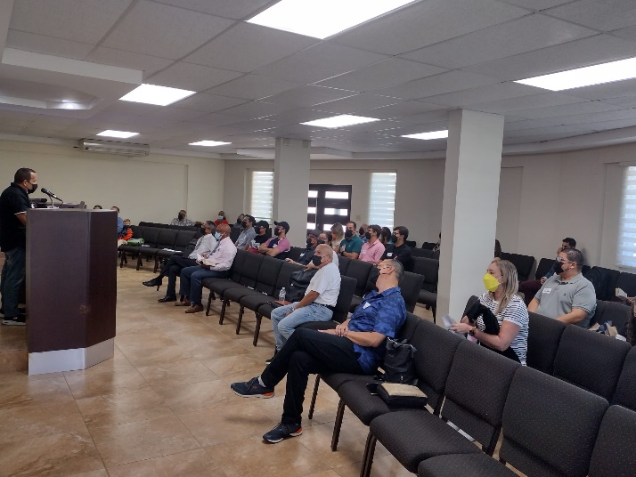
Each week I publish a bulletin in Spanish for the brethren in Arecibo and in San Sebastian. These articles have opened doors for teaching and discussions with the brethren here. Edwin and I have had numerous studies on the articles and he helps me edit them. He is also helping me edit some of my other bible class material, particularly on the series on authority I wrote. We are looking to start to use that material soon in our studies. I have had opportunities to preach publicly at Arecibo and recently the brethren have asked me to teach some of the weekly bible classes. Coming up soon, I will be teaching some basic lessons on authority using Old Testament examples, like Noah and Moses. This past month we also attended a bible study conference at Arecibo. There were about 35 brethren from different areas around the island. It was an interesting study that provided opportunities to engage with many of the brethren. We also had the opportunity to study with and encourage some of the younger couples at Arecibo at that meeting.
Bible study at Arecibo’s building

Work in San Sebastian
Even though we are fully moved to Arecibo my family and I continue to worship and work with San Sebastian. The San Seb building is about an hour’s drive away and we go each Sunday and Wednesday to San Seb. I recently started a bible study class on the use of the collection, and I am very happy to see everyone’s feedback. One of our perpetual visitors, Alfonso, who has a background in Pentecostalism, is beginning to see the truth regarding the collection and now openly admits that his previous assumptions and beliefs were wrong. The other brethren have had excellent questions and the study is going very well. This past month, Eladio, (who used to visit with us regularly years ago), returned to visit us again. He has visited us twice and seems to be more open to discussion than he was in the previous years. We hope and pray that he will seek the Lord. Brother Felix has a friend named Merri, who is originally from Medellin, Colombia, and I have had the opportunity to sit down and study with her and Felix. She is quite timid and had some bad experiences with churches in the past, so she has still not visited our bible studies, but she is open to having personal studies with Felix and me. So, we now have a weekly study at Felix’s house each Wednesday afternoon. Brother Carlos Moscoso was hospitalized for about a week due to an infection in his arm. We were very worried about his health situation since the doctors could not find what was causing the problem. We prayed fervently for his recovery, and we give thanks to God that he seems to have made a full recovery without any problems. It is a blessing to have them back with us in San Sebastian now.

There are many more studies and plans that we are trying to accomplish here in Puerto Rico. We are blessed with an abundance of opportunities and work. We would truly appreciate your prayers on our behalf and for the work here. We have been blessed to receive different visitors from the states this past month. Kaitlin’s mother and grandmother came to visit, Reagan McClenny (who preaches in Lufkin, TX) and his family stopped by for a nice visit, as well as 3 sisters from Tennessee (friends of Kaitlin) stayed with us a few days this past month. Our spirits have been uplifted and even though we have been extremely busy. It has been a blessing to renew our bonds of fellowship with everyone who has taken the time to visit us. We are so thankful for the communion and relationships we have in Christ Jesus our Lord. This next month we look forward to the arrival of Jonathan Carswell and his family to the island. They are from Alabama and are planning on staying a month here in the Arecibo area. We are excited to get to know them better and work together with them for that time.

Thank you for your continued support and fellowship. We would not be able to do this work without your help and we give thanks to God for the mutual participation that we share in the gospel. If you have any questions about the work here, please feel free to contact me anytime. I am at your service. May our great God of creation and peace always bless you abundantly and keep you ever in His care!

Grace be with you always,
Caleb B. Westbrook

