Puerto Rico Work Report (August 2022)
Caleb Westbrook – HC 2 Box 47421, Sabana Hoyos, PR 00688
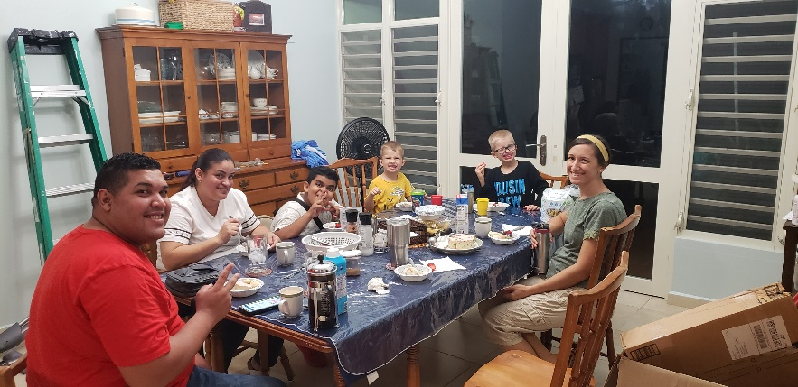
713-304-9770/ westbrookcaleb@gmail.com

Greetings Brethren in Jesus our Lord,

We pray that God is blessing your work for the Kingdom and that all is going well for the saints there. God is faithful, no matter the challenges that come our way. In roads of ease or valleys of despair, our sovereign Lord always remains true. This past month has been personally challenging for me because I have been battling a nasty infection with mycoplasma. Mycoplasma is a type of bacteria that causes respiratory infections, sometimes the infections can be called walking pneumonia. About a year ago I had a rather severe mycoplasma infection that caused me problems for over a month. Sadly, it seems that I have found myself in a similar situation. Thankfully, Kaitlin and the boys have not had any issues at all. I would appreciate your prayers on my behalf. This infection severely hinders my work and access to study with others. I trust in God for His healing, and once again I am reminded of how precious of a gift it is to have good health. It is even a greater motivation to work diligently when we are blessed with good health and opportunity, for there will come times when we cannot do that. We must work and prepare in faith!
Ramon, Maribel, and their son Sebastian visiting our house for dinner

Despite the difficulties, Kaitlin and I are thrilled to announce that we are expecting our third child this next year. Kaitlin’s pregnancy has gone well this far, but we would appreciate your prayers on our behalf. We give thanks to God for the amazing blessings that He provides!

The Work in Arecibo
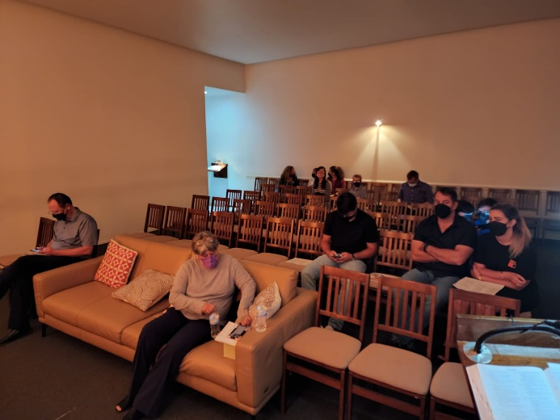
This past month one of the brethren here in Arecibo passed away. His name was Erick Cruz and I had mentioned him several times in my past reports. Erick and his wife Diana had been baptized at the end of 2020 and they had studied with brother Edwin and me on numerous occasions. Erick and Diana were the couple that had questions on marriage and divorce and were at the genesis of the controversy on marriage and divorce (MDR) that is still happening at the Arecibo church. Erick was always happy to receive us and was eager to study the Bible with Edwin and me. Erick and Diana seemed to not agree with the Arecibo brethren’s position on MDR, but they did struggle with ironing out some of the sacrifices and demands of repentance that they needed to follow. Nevertheless, they were always willing to study with me. One evening I got a call from Edwin telling me that brother Erick had passed and immediately I rushed over to their house in Camuy (about 30 minutes to the west). Erick’s body was still in his room and Diana was in shock. Edwin and I helped as best we could and soon after the coroner and helpers from the funeral home arrived. We spent most of the evening with Diana and we had numerous opportunities to talk with her friends and neighbors about the gospel that night. One of Diana’s neighbors, Santiago, stayed and talked with Edwin and me for about an hour and a half. Even in the midst of sorrow, God can open up doors of grace and opportunity for His service. Erick was not in good health, but it turns out that he had mycoplasma. Apparently, it was at his house where I came in contact with the bacteria. Sister Diana has had a difficult time and we have been trying to help and encourage her. At Erick’s funeral service I was able to lead singing and brother Edwin, along with a few others from Arecibo, gave some encouraging words. I am saddened by the loss of brother Erick, but we were blessed by his interest in the gospel and his movements toward repentance in the short time that we knew him.
Brother Erick’s funeral service

Edwin has been a source of continued encouragement. He has grown so much in his knowledge of the Word. I recently purchased copies of Donnie Radar’s bible class workbook, “Marriage, Divorce, and Remarriage,” for Edwin and me to work through together. It is the first time that Edwin has ever studied through a bible class workbook, and he is soaking up the information. Edwin has the advantage of speaking and reading English well (He spent 30 years as a US Army contractor working worldwide), so he has no problem with English materials. I have also been introducing him to Bible dictionaries, interlinear Bibles, and deep word studies in Greek and Hebrew. I have truly been amazed at how well he is picking everything up, even though in his humility he claims he is learning slowly. With his increase in biblical knowledge, Edwin’s zeal has continued to grow. As I mentioned in previous reports Edwin had invited his brother Tony (who preaches in Aguadilla, PR) to study with us. This past month we studied via Zoom (since I have been sick) and Edwin brought up the topic of marriage & divorce with Tony. At first Tony did not agree that the Bible only gave 1 cause for divorce, but after calmly bringing him back time and again to Matthew 5:32, Tony finally admitted that it was true that there is only 1 biblical reason for divorce: sexual immorality. I have been encouraged to see the fruit and growth that is happening through Edwin and the studies that he is having, it is an honor and privilege to be a part of the work with him. To God be the glory!

It is very interesting to note that with Edwin, Tony, Erick and Diana, all of them had previous issues with marriage and divorce in their lives. Sadly, some of the brethren at Arecibo that teach error on MDR say to me, “Caleb, if we teach what you teach then no one will be part of the church!” They are afraid and judge that the words of Jesus are too harsh, and they believe that people won’t truly come to repentance. In the cases of each of the 4 people that I mentioned, each one of them would be considered by most to be bad candidates to discuss MDR because of their past history with the topic. Yet, it is these exact people who have struggled with the issue that have shown interest in studying it and have demonstrated the most repentance so far. The irony does not escape me. Too many times Satan wants us to dilute the gospel to make it more palatable for people based upon what we perceive they would accept. When we sacrifice the truth about repentance, we not only distort the gospel of Christ, but we also judge other people to be incapable or unworthy of repentance before we even give them a chance to hear the saving truth of Christ’s Word. This point has been impressed upon me so much over the past few months. Too many times I have worried about what topic to present or how exactly to present an issue when I should have had more faith in the power of the Spirit through His Word to convict others of sin and call them to repentance. May God help us all in our pride and lack of faith in this struggle. May we stand strong with His truth and never compromise it!

We have had many other opportunities for studies over the last month here in Arecibo. Kaitlin and I invited the young couple, Ramon & Maribel, over to our house this past month. They brought their son, Sebastian, and spent several hours with us, and we were able to have a bible study with them. There is much work to do with them and with others, but we continue to sow the good seed in faith. Kaitlin has continued to be a force for good with the ladies’ classes and she has been helping many of the sisters here. Even though we have been met with opposition by a few at Arecibo, we are not giving up and remain resolute in our mission to do the Lord’s work here.

The Work in San Sebastian
My work in San Sebastian continues to go well. I am teaching through the book of Matthew and have recently finished a sermon series on the New Testament church. Additionally, I have been continuing to study individually with Felix and his wife Merri. Merri is still showing a lot of interest in our studies, and she has been attending regularly with us on Sundays. The brethren at San Seb have been very encouraging and helpful during my illness and I am grateful for their prayers and support. I continue to produce new material each week for the weekly bulletin I publish for both San Seb and Arecibo. I am currently working on more plans for evangelism and bible class material that I hope to be working on throughout the fall. You can find most all of the materials I produce at solocristianos.com or at facebook.com/SoloUnCristiano

Thank you for your support, love, thoughts, and prayers. We are grateful for the fellowship that we share together in the work of the Lord. If you have any questions regarding our work here, please feel free to contact me anytime. May our God of infinite love and everlasting truth guide and protect you always!

Grace be with you,

Caleb B. Westbrook

