Puerto Rico Work Report (October 2022)
Caleb Westbrook – HC 2 Box 47421, Sabana Hoyos, PR 00688
713-304-9770/ westbrookcaleb@gmail.com

Greetings Brethren in the Kingdom,

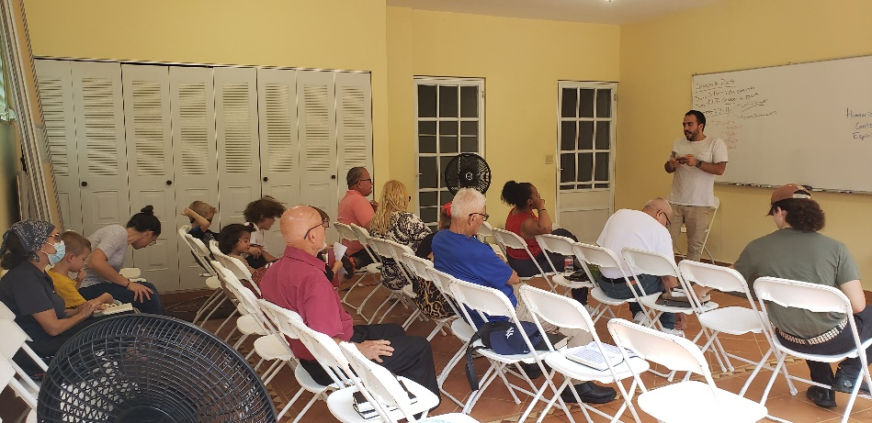
I pray that God will bless your work and keep you in His protective care always. Both October and the beginning of November have been a welcome return to a bit of normality after the hurricane in September. Due to the hurricane in September, a lot of my normal studies were interrupted. When there is no power or water many Puerto Ricans usually cancel all activities. After utilities are restored, there is always a rush to get back to normal. October was a welcome return, and I had the opportunity to get back to the normal pattern of weekly bible studies. On a normal week, I usually have between 5 and 6 personal bible studies as well as the other sermons and classes I present in San Sebastian and online. The work has been going well in both Arecibo and San Sebastian and this past month brought a bevy of new opportunities for us in the Lord’s work.
Roger Polanco leading the afternoon bible study at our house

Work in Arecibo
One of the main highlights of October was the visit of Roger Polanco and his family. This was the third time Roger has visited us here in PR and we are always greatly encouraged by the Polanco family’s work and visits. Roger and I have known each other for a long time, and we had the blessing of rooming together in college. Roger’s passion and teaching style are really appreciated by the Puerto Rican brethren here and they feel a closeness and kinship with him. Roger is Dominican, and the Puerto Ricans have a near familial connection with Dominicans and this further accentuates Roger’s connection and effectiveness with the brethren here. While Roger was here, he had the opportunity to preach in San Sebastian 4 times and accompanied me on several bible studies and discussions. Kaitlin and I also hosted an afternoon bible study activity at our house on the Saturday that Roger was here. We had around 20 people in total visit and even had some brethren visit from far distances like Yauco (about 2 hours away). Due to some of the difficulties that I discussed in my previous report, many people from the Arecibo group did not support our bible study. Nevertheless, we had a good number and Roger did an excellent job in all his lessons. Something that should be noted about Roger’s trip is that technically his visit to Puerto Rico was his family’s vacation time. Roger and his wife, Cassie, decided to use their vacation time to come and encourage us and help us with the work. They are a great source of encouragement to us, and we are so thankful for their sacrifice and focus on helping the Kingdom work. Both Kaitlin and I had the opportunity to spend many hours in conversation with Roger and Cassie and were greatly refreshed by our time together. The Polancos also have 3 boys around the same age as our boys. Abraham and Enoch really loved the opportunity to spend time with the Polancos and were sad when they had to leave.

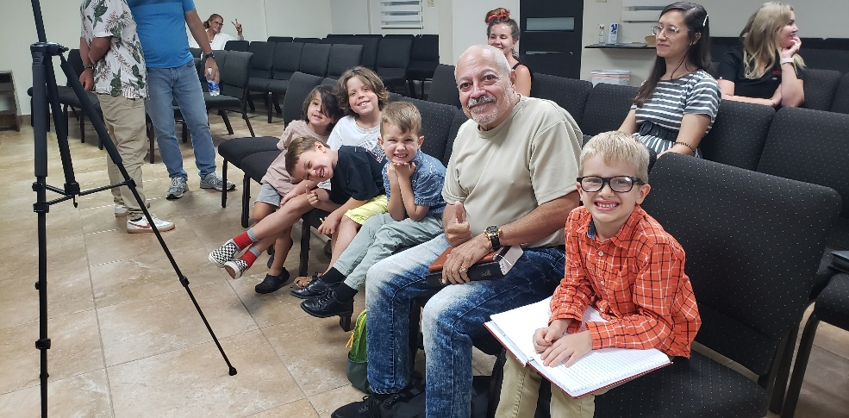
Roger’s visits, along with all the other previous brethren who have come to PR to help with the gospel effort, have an interesting impact on the brethren here in PR. First, these visits help expose the Puerto Rican brethren to more faithful teachers. Puerto Rico can be very insulated (even despite the internet), and many Puerto Ricans have no real knowledge, experience, or contact with brethren outside the island. This insular effect has both advantages and disadvantages, but one disadvantage is that some of the brethren regard me as highly suspect or even heretical because I do not fall in line with the institutional or denominational “church of Christ” practices here on the island. Many people here think that I am alone in my beliefs, and they can, in their minds, more easily write me off. Clearly, they should be persuaded by the truth alone, but that isn’t always how people think. So, when Roger and other sound brethren come to visit and the Puerto Ricans are impressed by their work and see the unity that I have with these brethren in our teaching, it gives them pause and makes it much harder to simply write me off. One brother in Arecibo in a private study recently asked me, “Caleb, do all these other brethren like Roger, Brigham (Eubanks), and David (Raif) believe like you do on issues of the church practices and topics like marriage? When I told him, “Yes,” I could see that the brother was impacted by this. He clearly has a lot of respect for the men who have come to visit, and it was apparent that he was taking my exhortations on doctrinal points with more weight because of the perceived legitimacy of the shared connection that I have with these other brethren. Another critical aspect of having brethren visit and help is that it gives an obvious signal that we are interested in investing in spreading the gospel to the Puerto Rican people. The time, sacrifice, and effort are noted and appreciated by many brethren here. Some Puerto Rican brethren will complain about my doctrinal teaching on truth, but no one can claim that we are not working or investing in spreading the gospel here. That example speaks volumes to the brethren here. I am thankful for all the men who have come to help and especially thankful to the Polancos for sacrificing their time and money to come to help us.
The Polanco boys with my boys sitting with Edwin at the study in Arecibo

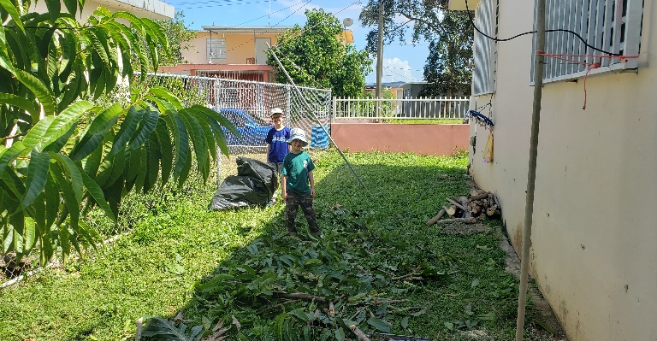
The past several months have been particularly difficult with some of the brethren in Arecibo who have wanted to force brother Edwin and me out of the church due to our teaching of the truth on marriage and divorce. At the beginning of September, Holvin tried to have us removed from the group at Arecibo. Thankfully his attempt failed. I was thankful to God that this past month I was contacted by the other two brethren from Arecibo, brothers Rene and Alvaro, to have individual studies and conversations on the controversy of marriage and divorce. Brother Rene was the first to study with me and he told me, “Caleb over the past months there has been a lot of talk about you and your teaching, but you haven’t been given the space to explain yourself without being interrupted by others. I would like to just listen to what you have to say.” I was incredibly thankful for brother Rene’s openness and he and I had a 5 ½ hour study together that day. Even though Rene didn’t come out and say that he changed his mind or agreed with me, there was an openness and a willingness that he expressed to continue to study with me. I give thanks to God for that open door. Similarly, I had a private study with Alvaro, and we had a productive conversation. Additionally, I am continuing the studies on the topic of marriage and divorce with brother Edwin, and he is continuing to grow more each week. This whole process has been very challenging, and it will take a while for there to be any resolution. Nevertheless, I am very thankful for the progress that has been shown over the past month. This matter requires a lot of patience and perseverance and I pray that God will help me have the wisdom and patience I need to correctly manage this trial.

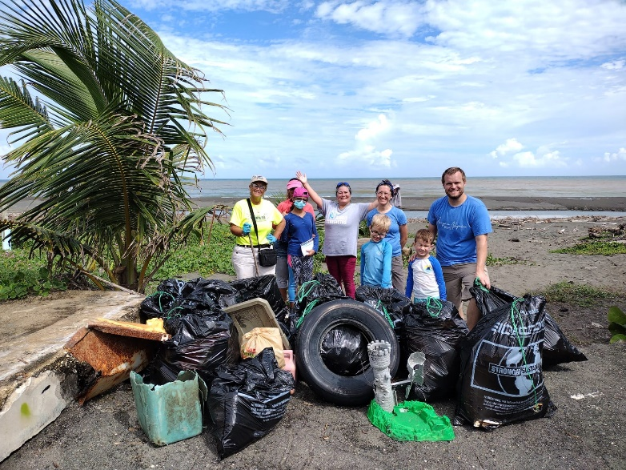
The past month has offered a lot of opportunities to connect with people through acts of service. My boys, Abe & Enoch, and I had the opportunity to help sister Margarita from the church in Arecibo with pruning and removing trees from her yard. It was a lot of work, but we had opportunities to meet and talk with Margarita’s family and her neighbors. I was thankful for my boys’ help and glad to see that even though they are small they can also help contribute to the work here. My family also had the opportunity to go help sister Rosie from the church in Arecibo with a community project to help clean up trash from local beaches. Sister Rosie lives in Barceloneta (the next town over to the east of Arecibo), and she invited us to help with the beach cleanup. We enjoyed our time with her and had the opportunity to meet some new people from the community. It was a blessing to be able to enjoy God’s creation and to help a sister with a good project.
Abe & Enoch helping with tree removal at sister Margarita’s house

Edwin and I had the opportunity to visit sister Annie Soto who is a shut-in member in Arecibo. It has been challenging to try to find time to visit all the shut-ins and weaker members from Arecibo because there are around 20+ people that we need to visit. Further, it is difficult to try to coordinate all those visits with Puerto Rican schedules (I still to this day have trouble understanding how some Puerto Ricans schedule their days). When we visited Annie Soto, we found that she was very discouraged by the lack of visits and interest from the members at Arecibo. It was challenging to try to exhort and encourage her while also seeing the impact of the lack of engagement from members at Arecibo. Some people have gotten into a bad habit of being insulated and not connected with other members. The pandemic had a very negative influence on this disconnectedness. Edwin and I are trying to encourage people to get back to the biblical pattern of serving and caring for one another. However, we find that many people are just too wrapped up in their own world to do much of anything else. Nevertheless, we press on in our encouragement and exhortation of others.
Beach cleanup with sister Rosie

Edwin and I have really enjoyed getting back to the normal pattern of bible studies and have picked back up on our usual studies with sister Yadimar on Thursdays and with sister Diana on Fridays. Sister Diana has also invited her mother, who is not a Christian, to our studies and her mother has expressed a lot of interest in the classes that I have given. Additionally, this past month I started up a weekly study on Friday mornings on the book of James and we are trying to promote more participation. The study is trying to focus on the importance of biblical context and complete readings of the text. We have had one young man from the community express interest in the study and I hope that he will join us soon.

Work in San Sebastian
Everything with San Sebastian has been going well. The Moscoso family is still visiting their family in New Jersey and we do not know when they will return. Despite their absence, we have had good attendance from our other members and have had more consistent attendance from some of our perpetual visitors. Sisters Estrella and Kiara, who live in north San Sebastian, have been much more consistent with their attendance on Sundays and we are thankful for their participation. I have been continuing to teach the book of Matthew for the church as well as teach personal bible studies for Felix and his wife Merri. This past month we also had an opportunity to visit sister Elba Torres who is a member at San Seb. It was a blessing to be able to spend time with her at her house and we are always encouraged by her dedication and faithfulness. Not only is she a faithful sister in Christ, but she is also a good friend to our family. We are very thankful for her.

I have started writing bible class material for the next study in San Sebastian and it will be a comprehensive study on marriage & divorce. Not only has this topic been a focus in Arecibo, but through the classes in Matthew in San Sebastian, I have received a lot of questions about the topic of MDR in San Sebastian. There is so little bible class material available in Spanish and I am hoping that this series will be of help to both the brethren in San Sebastian and in Arecibo. Lordwilling, I am planning on making this material available through my website, solocristianos.org, where I publish my bulletin articles and other bible materials that I have written and translated.

Prayer Request
One last thing I would like to mention is a request for prayers. Recently brother Edwin has been very sick with a virus that has caused him a lot of problems. I ask that you please pray for him to recover. Edwin is such an important co-worker in our efforts here and he is vital in my studies and connections with people here in the Arecibo area. I pray to God that Edwin recovers and that he has strength and good health for many years to come. He is a light and example to the brethren here and I pray that he can continue in the work with us without any hindrance. Thank you for your prayers on his behalf!

As always, we are filled with gratitude and thanksgiving for your interest and fellowship in our work here in Puerto Rico. The faithful brethren here send their greetings to you and the saints where you work. If you ever have any questions about the work here in Puerto Rico, please do not hesitate to contact me at any time. May our sovereign God of peace and beauty fill your lives and work with blessings!

Grace be with you,

Caleb B. Westbrook

