Dear Brethren
I hope I find you doing well. In Zimbabwe we are very grateful that God is keeping us well and sound. All the brethren I work with do not have many unusual health issues to complain about. We are thankful about that. The following is the summary of the work I did in March 2022.
On the 6th of March, I travelled with Nothando to meet with three congregations in the Bera region. We were going to visit only one congregation which is new in the area called Chenhare. This congregation has some of its members who are former members at both Bera and Ruware. It has new people from the area who have joined them. There are three congregations now in the area. When brethren at Bera and Ruware learnt that we were visiting the area, they also extended their invitations. It was not possible to visit them all one day because they start their services around the same time. So Bera and Ruware arranged to change their times so that we would be able to visit them also. Our first port of call was Chenhare. In their bible class they asked me to briefly teach on the origin of the Church of Christ and why its members are not identified by a certain uniform like we see in the denominations and even in the liberal (institutional) church of Christ. I obliged. I was also asked to preach and I preached from Colossians 3 which is one of the best New Testament chapters that teach new converts how to behave when they have obeyed the gospel. As soon as I ended the preaching, we left to Bera where brethren had adjusted their starting time from 9am to 11 am. I even forgot to take a photo of the brethren at Chenhare as we left in a rush.
We proceeded straight to Bera meeting place about three kilometres away. In the bible class at Bera I made an overview of the book of James. I am intending to teach this book soon to all the rural congregations I work with. My sermon was then chosen from the first chapter of this book focussing on verse 19-20.

Brethren present at Bera
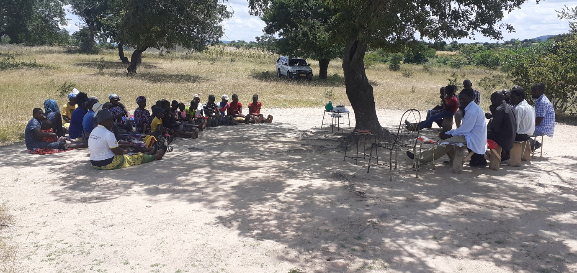

Immediately after the lesson, we left to Ruware. The brethren had adjusted their time to begin at 1pm. At Bera in the Bible class I was asked to explain the Tabernacle and all its features. In the sermon I introduced the book of James. We finished at 3pm and immediately left to Bulawayo over three hours away. Brother Allen should be prepared for that programme for he will teach six times at the same congregations on Sunday 17 April. The brethren have made the same arrangement of changing their meeting times to accommodate the visiting preacher.

Below: Ruware brethren present
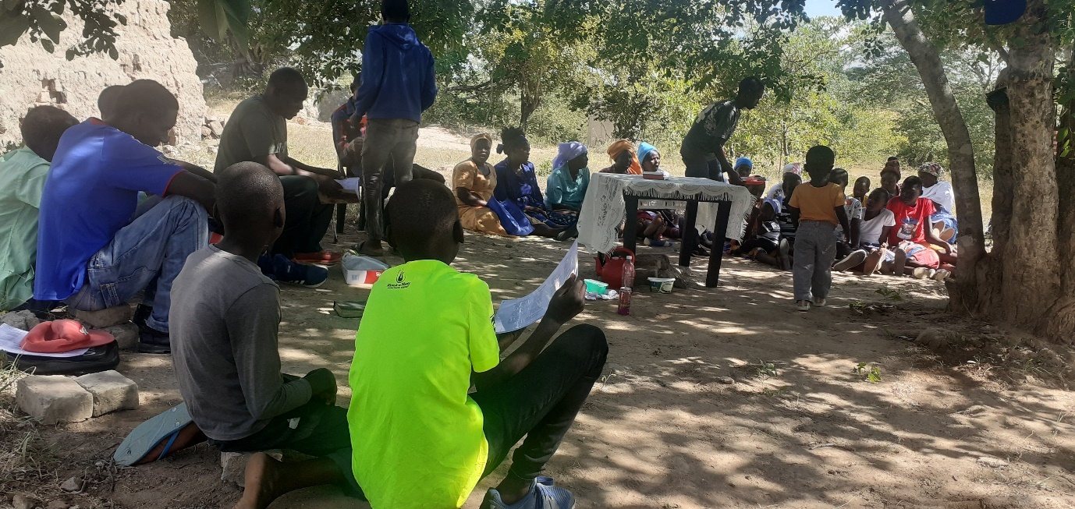
On the 13th I was back at Hillside. In the morning studies I am teaching the book of Mathew. My sermon was entitled “How do Christians respond when faced with problems”. I used examples of Bible characters like Job, Daniel and his three friends, Paul and many others who were tortured due to their loyalty to God. This lesson is uploaded on You Tube and searching for Professor Mashoko gives access to this and other material uploaded.
On Sunday 20, I again taught from Mathew in the bible class and preached from 2 Kings 20. We learn of the mistake of king Ahab of sparing the life of Benhadad king of Syria and this mistake came back to haunt him three years later. I had a technical problem with my phone which I use to record the sermons and as a result I failed to record the lesson.
On the 28th, we received nine men from different parts of the country at our house in Bulawayo who were coming to study the Bible periods (history and geography) with me. We began the classes on Tuesday starting the classes at 8:30 am and ending at 6pm. We would have an hour lunch break. Brother Allen was a guest speaker who taught the class for an hour on Thursday the 24th from the period of the Judges with particular emphasis on Samson. The lesson was on Zoom. I concluded the studies yesterday Saturday 2 April. After attending church service today at Hillside, the men left to their respective places. The furthest men will travel for 700 kilometres to Nyanga.

Below: Men getting ready for class. I am wearing blue top to the extreme right
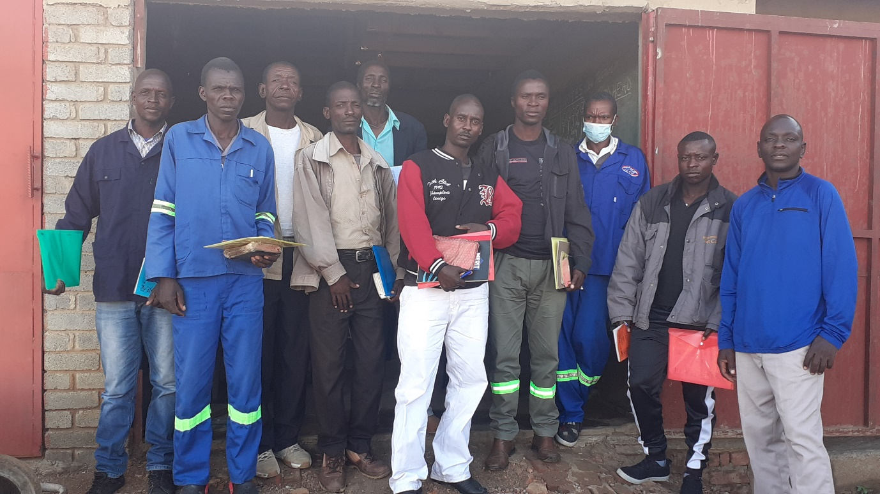
Thank you brethren for supporting this work. We are looking forward to receiving brother Allen and Sister Debbie in just over a week’s time.
Drought Situation
Beginning end of April, if KSR is in the position to help, the brethren in the rural areas will need your hand as usual. We will give more information in due course.

Professor

