Greetings to you brethren. It is always our hope that when we send these reports, they find you all in good health together with your families. We hope too that the flock of God that you oversee is doing well. In Zimbabwe we are thankful God is keeping us safe. We do not have many health issues that are out of control amongst the brethren I work with. Those that are not feeling well have normal ailments that are manageable as I am reporting. The following forms the core of my work in November 2022.
Thursday 3 November 2022
I taught two lessons at Masunda from 4pm to about 6pm. I had been asked to teach on giving and that was the first lesson. The second lesson was on PowerPoint and it was titled Anger Management. This is a lesson that I had taught at Hillside and I decided to repeat it at the rural congregations as well. The lesson is uploaded on You Tube with the same title. Unfortunately, I did not take any picture at Masunda.
Friday 4 November 2022
From 9am to 3pm, I taught 30 men at Ruware. The men were drawn from Masunda, Ruware, Bera and Chenhare. The venue was the recently built Ruware building. I taught the general timeline of the Bible. The study was well received. Many of these men became Christians from different denominations where the Bible is not taught in detail. So, they are discovering new things in our classes hence are very excited. The following picture shows the inside of the building with the men from Ruware John Makopa in black and Solomon Manzunza inside.
At 5pm women from Bera, Ruware and Chenhare joined us for combined studies. I taught the same lesson Anger management from PowerPoint and I answered a few questions that were asked after the lesson. We finished around 7pm.
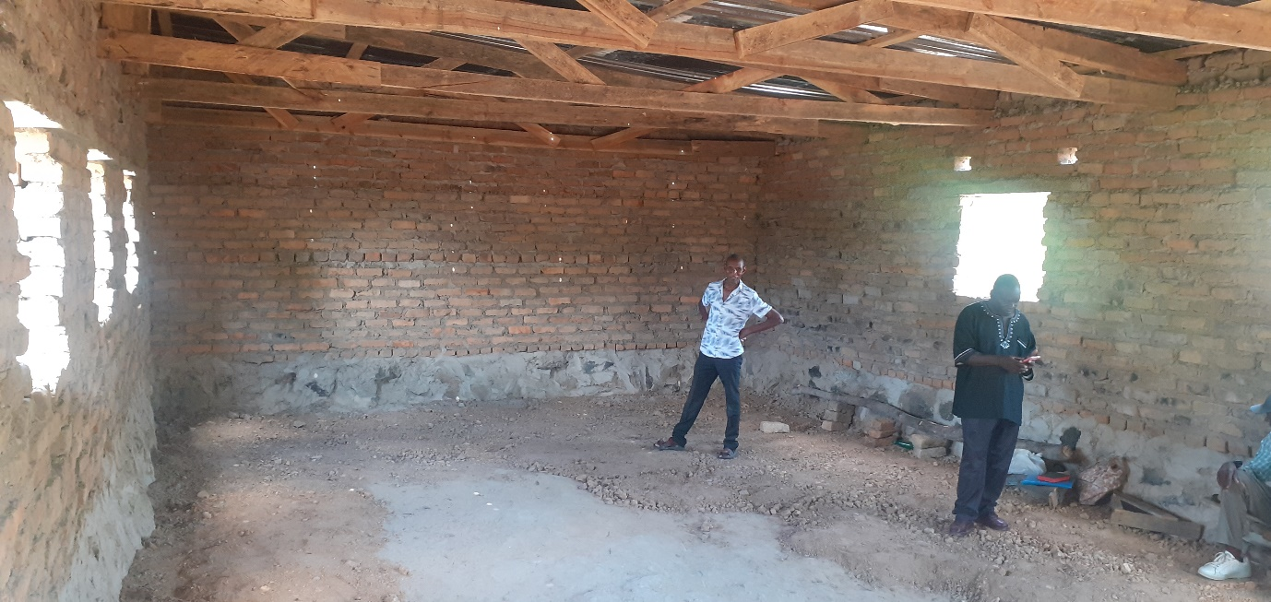

Below is a picture of men who attended the Bible timeline class
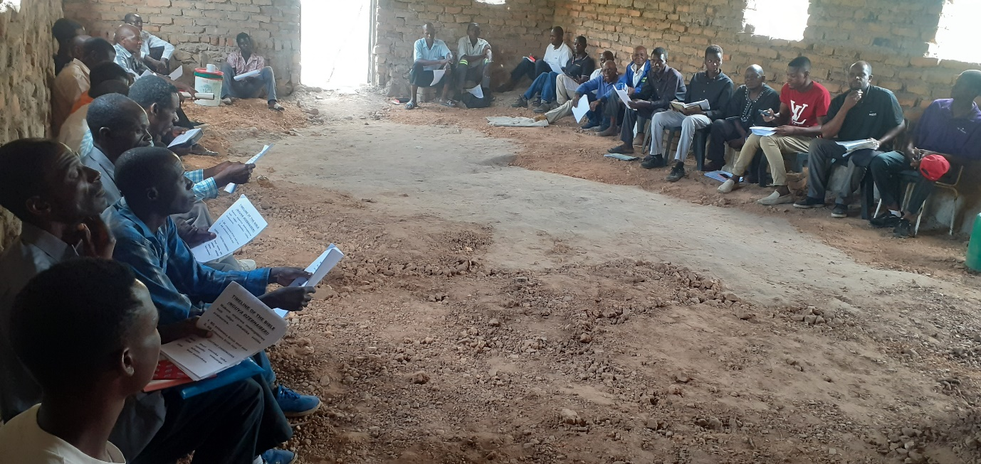
Below are two pictures of brethren listening as I was teaching from PowerPoint. I am seen in the second picture standing holding my Shona bible.
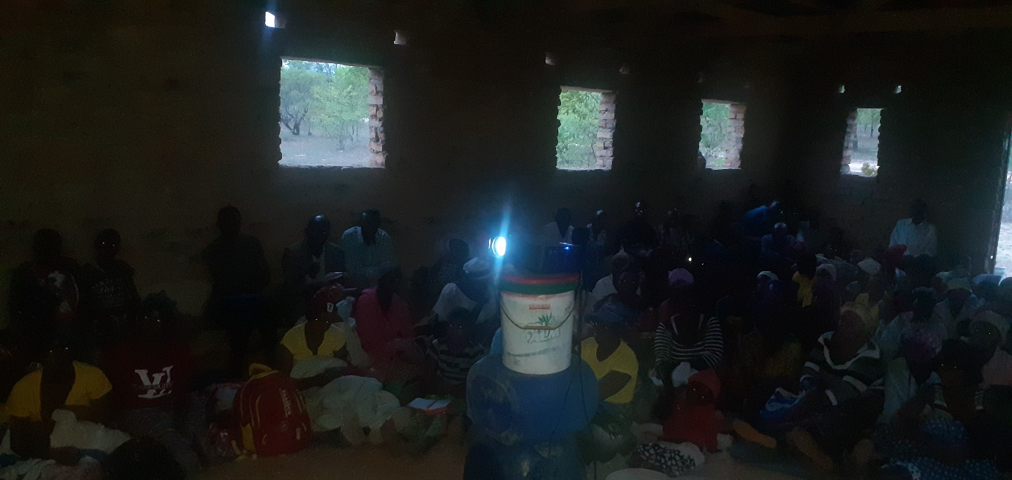
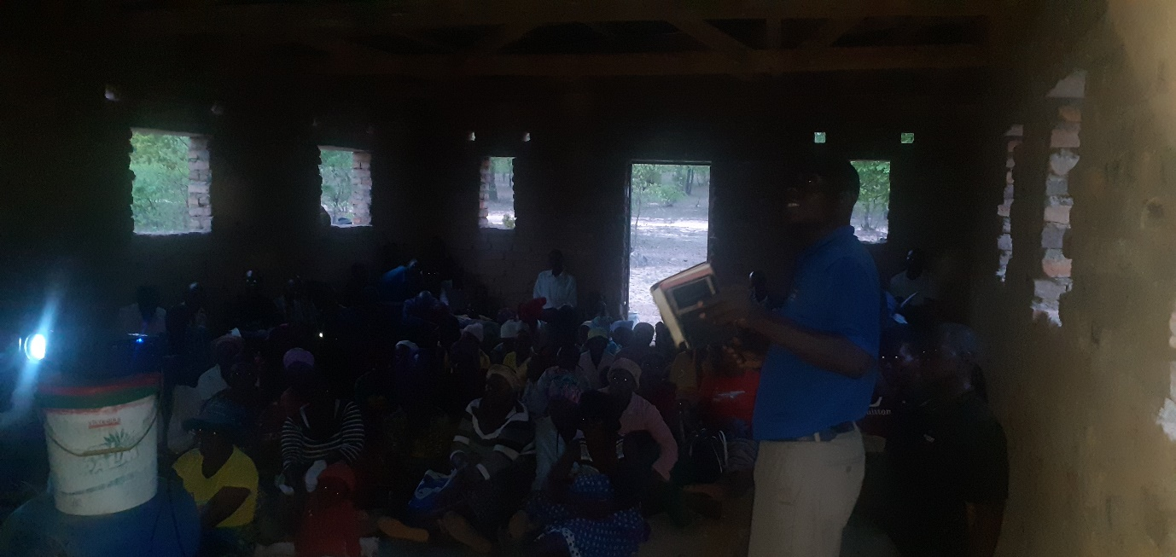

Saturday 5 November 2022
At 6pm I was at Chitowa where I again taught the same anger management lesson. Just like at Masunda, at Chitowa I did not take any photo.

Sunday 6 November 2022
I met for worship with Mberengwa congregation. I taught the bible class and preached from the book of Proverbs. After meeting these brethren, I left for Bulawayo 200 kilometres away. On the day the Mberengwa brethren did not use a tree they normal use as a meeting place. The ground was wet from some light rains. The whole place under this tree was infested with big brown ants that were patrolling. We tried to be rebellious against them and go ahead with the service but they were climbing on us making concentration impossible. So, we changed base and gathered at a member’s home which is close by. The man in yellow in the following picture is the member whose home we used. His name is Mufaro Majasi. He was not feeling too well on the day. The latest I got just today in the morning is that he is doing much better now.

Below is me in greenish shirt holding a bible gathering with the Mberengwa brethren around a hut. It was very hot on the day.
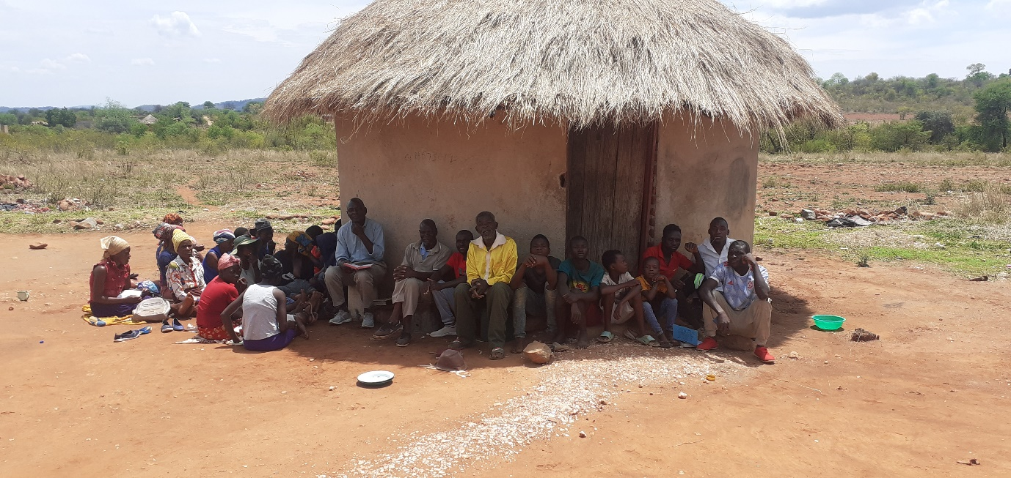
Sundays 20 and 27 November 2022
I was back at Hillside. The previous Sunday on 13 November, Predecessor my son got his second preaching slot. Him and another young man called Parvel Sigauke get preaching opportunities here and there to prepare them for the future if they remain dedicated. Hillside will need such men soon. Alan Bent who was one of the two preachers is now 80 and has drastically slowed down. His hearing is bad now and he now forgets a lot of things. Inevitably, and any time soon he will retire. He essentially preaches when I am away. The coming in of the two young men will help a lot especially when I am away and obviously in the future when we all get old and can’t do much.
I then preached on 20 and 27. It was one lesson on giving which I divided into two parts. The two sermons are both uploaded on You Tube. The first part preached on the 20th was introducing this subject and laying the background and was anchored on Exodus 36:1-7 particularly verse 5 where people kept bringing in freewill offerings to do the work of the Lord until they brought more than enough. Moses had to restrain the people. The second part preached on the 27th was then concluding the subject and focuses more on New Testament teaching on Christian giving. On You Tube, the first lesson is titled “The teaching and the attitude of the people of God towards giving to him” and the second is titled “Giving for the saints”. I always remind that searching for my full name Professor Mashoko on You Tube gives access to these and many more lessons uploaded.
Immediate future plans
Lord willing, I leave Bulawayo with Nothando and our five boys on Thursday 8 December to the rural areas. There is a Ladies’ meeting that was organised and will run concurrently with youths meeting at the same venue which is Rutedze Primary School. The classes start on Thursday evening and end on Saturday the 10th in the morning. Schools in Zimbabwe close on the 8th and only open second week of January 2023. Nothando is the main speaker in the ladies’ class. There are two other ladies who said they will have a lesson each to teach. I have worked a lot with her as she was preparing her lessons. Predecessor is one of the teachers in their youths’ classes. There are three more young men who will also teach. I will only teach combined class on Thursday evening and Friday evening and also help answer questions that will arise from the ladies and youths’ classes. This is the beginning of the rains here and if the rains don’t disturb, we expect over 100 ladies that have confirmed their presence. They are drawn from Masunda, Chitowa, Mberengwa, Bera, Ruware and Chenhare. The youths are drawn from the same congregations also. There was no better time to do the classes except on those dates since having such classes during school days is not possible. We are helping as far as we can with transport and food for these brethren. we are excited and pray for the success of the classes.
Thank you all for your prayers and financial support.
Your brother
Professor

