Dear Brethren
I greet you from Zimbabwe in the name of our Lord. We believe you and your families are doing well. We believe too that the Lord’s flock under your watch is doing very well. We thank our Father in heaven for keeping all of us safe. In Zimbabwe we are thankful God has kept us fit and fine until now. The year 2022 is coming to a close and we are all very grateful. The brethren I work with both at Hillside in Bulawayo and in the rural areas are not having any unusual health issues. That is a cause of joy for all of us. I look back into the year as largely fruitful in terms of equipping and edifying several souls with the gospel. The following will be my last report of 2022.
Sundays 4 & 18 December 2022.
I was at Hillside where I concluded the book of Genesis in the morning studies before service. I had been studying the book with the brethren for a few months. We still need a week or two into the new year to fully revise the book and find another book or topic to fill this slot. I permanently teach this class every Sunday when I am at Hillside except when I am travelling. On the 4th Parvel preached and on the 18th Predecessor my son preached. The young men preached three times each so far as I have been encouraging them to do so. There are some notable improvements in their presentations even though they still need to continue working harder. I am preparing them to be available for Hillside when I am visiting rural congregations. As I mentioned before in one of my previous reports, Alan Bent who was one of the preachers for Hillside for a couple of years is now on the other side of eighty years and has seriously slowed down.
Thursday 8 to Saturday 9 December 2022
On Thursday Nothando and I left Bulawayo headed to the rural areas. The destination was Rutedze Primary School over 200 kilometres from Bulawayo. Ladies were going to host their classes concurrently with youths. The classes began on Thursday afternoon and ended on Saturday morning. Around 200 people both Ladies and youths attended. Less than five men including myself were present helping especially with the logistics. I also came in handy in the evenings answering questions that would have emanated from the classes. I also had an opportunity in a two-hour long session on Friday to teach the teenagers various issues mainly dangers of early marriages, unplanned pregnancies, sex before marriage, general life vices etc. I made it to be a no holds barred interface where they freely expressed their own life challenges. It was a very fruitful discussion hearing them air their practical views and their day today teenage struggles and being able to provide them with Biblical answers.
The classes were divided into three. All the ladies were in one class where Nothando and a few ladies presented different lessons. It was also an open discussion where the listeners had opportunities to share their own life experiences. My personal survey revealed that they had a wonderful time together. This was the first ever such meeting where ladies met away from men and freely talk issues that are exclusively to women and having the Bible to moderate the discussions. They asked for more such opportunities in the future. The youths’ classes were divided into two. The primary school going were in their class while the high school going and beyond formed the other class. Older youths namely Ishmael Bwatikona, Fredy Chomurenga and Miracle Muvondoni took turns to teach the youths classes. Predecessor my son who was supposed to be one of the teachers failed to travel because he was needed for a job interview on the Friday the day of the classes. I then helped with teaching the older youths as I explained above. I enjoyed every bit of the classes. We hope to have at the least one such gathering in 2023. It is beneficial to hold the gathering during school holidays. Zimbabwe has school holidays in April, August and December. The attendees were drawn from the usual six rural congregations we work with namely Bera, Ruware, Chenhare, Masunda, Chitowa and Mberengwa. Nothando and I met the bigger costs of the meeting including buying the food that was eaten. Sandi Kendall Ball sent $150 to Nothando which she used to meet some transport costs of the ladies who came from far away.
Below: Group photo at Rutedze. I am squatting with white shirt at the centre of the picture
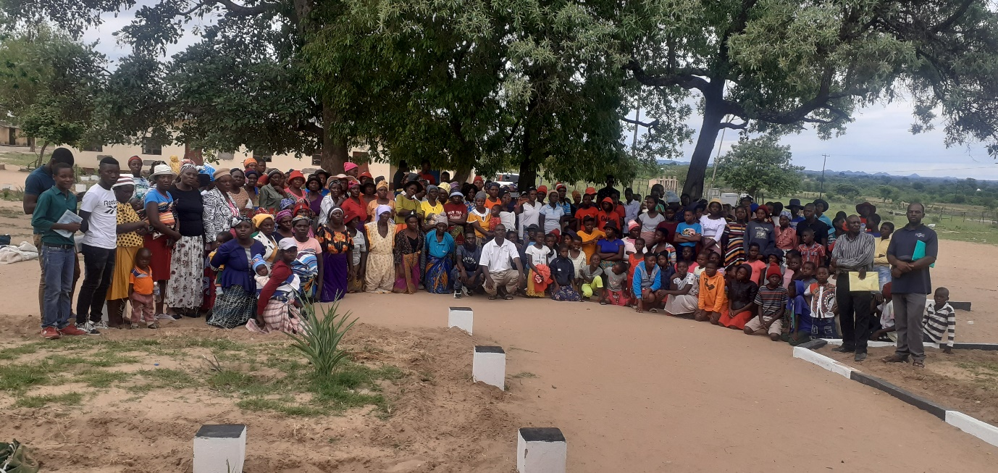
Below: Ladies came forward to get a photo. Nothando in black top at the centre
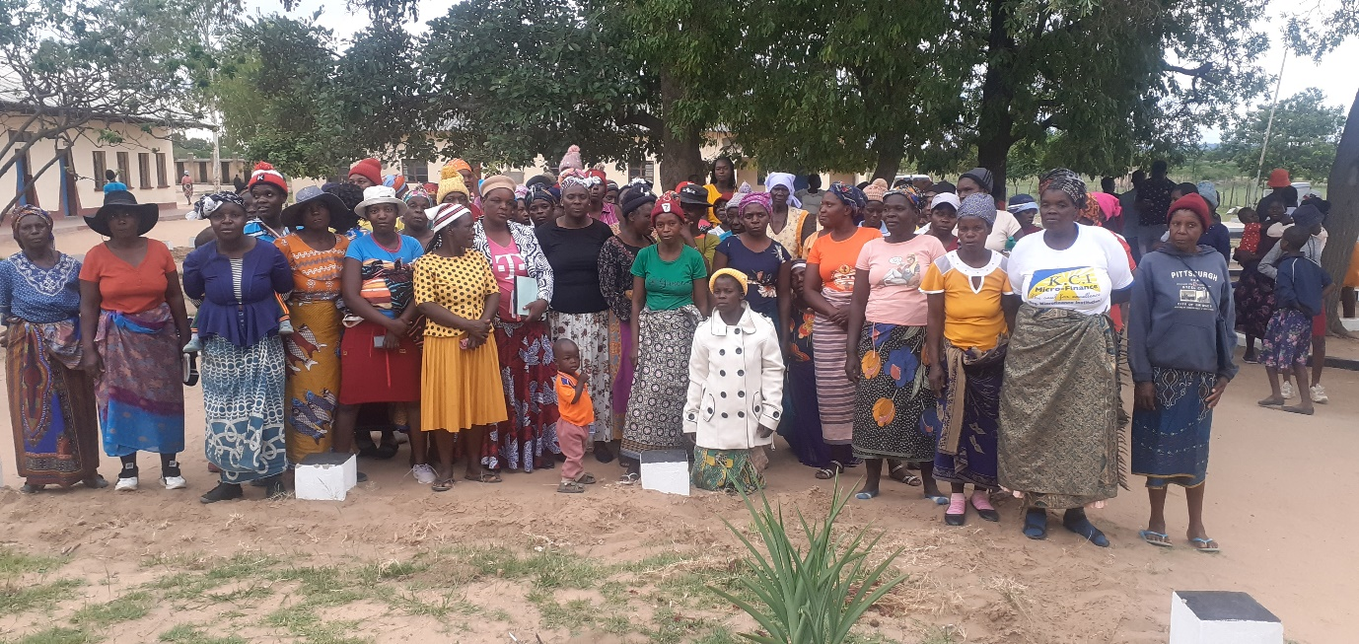

Below: Teenagers in the class. I am sitting far right in white shirt

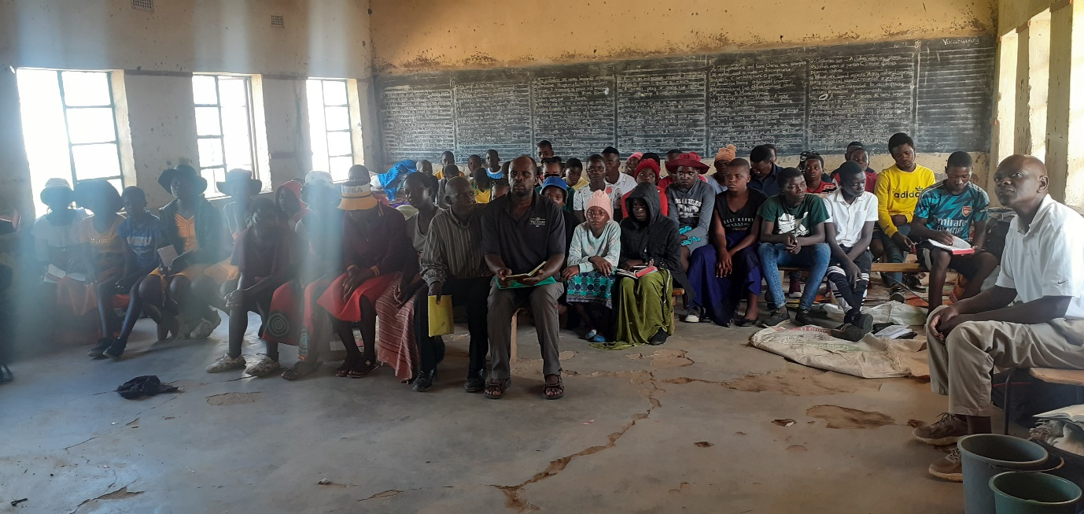
Below: Primary school going youths in their class
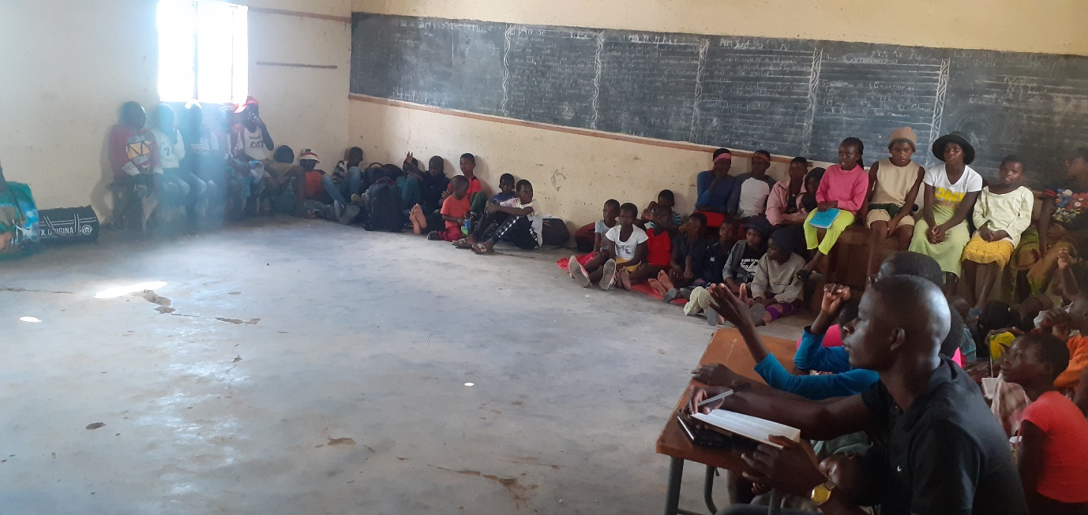

Sunday 11 December 2022
We met and worshipped at Masunda. I taught during Bible study. The congregation was dealing with a case of an old man. He became a Christian in 2009. Around 2015, he stopped coming to church. During these years of backsliding, he divorced his wife. His first wife passed away many years before he became a Christian and he married the one he was with in 2009 when he became a Christian. She was baptised also in 2009. They both stopped coming to church and divorced for an unscriptural reason. The man has come back to church and wants to marry another woman. I was asked to teach on this situation and I taught the position of the Bible in such situations and told the man that he can’t marry the woman he wanted to marry for he is still scripturally married to the divorced woman. I was also asked to preach and I preached on the birth of Jesus as recorded in the two books of Mathew and Luke which do not provide us with the actually date or even a command to celebrate the birth as opposed to what is taught during Christmas time.

Below: Masunda brethren present on the day
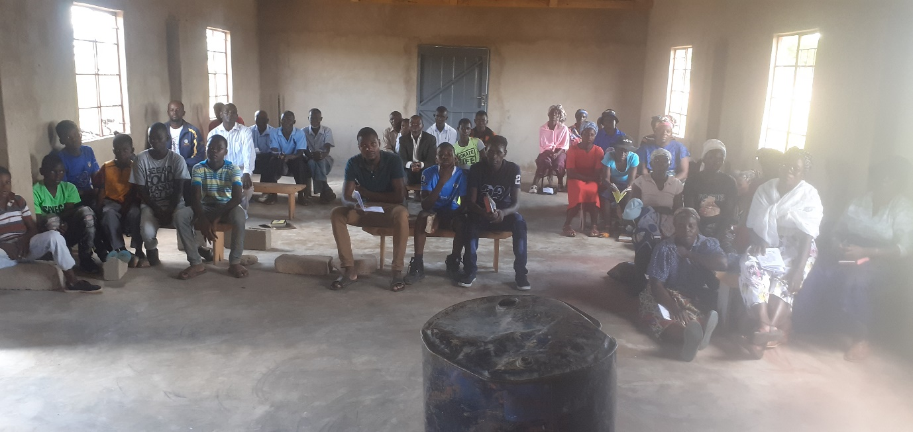

Sunday 25 December 2022
Nothando and I travelled back to the rural areas on Saturday 24 December. We were scheduled to meet with Masunda and Chitowa brethren. However, the meeting at Masunda was cancelled due to a death in the village. The deceased person was being buried on this day and the burial place was a stone throw away from Masunda church building. We all ended up attending the funeral. In the rural areas, it is almost certain that when there is a death in the village especially a burial which coincides with Sunday, church services will be cancelled. Every villager is required to abandon all their chores and attend the funeral. This is not the case in urban centres where people are not always a closed knitted community. Rural people know each other by name and can easily tell who was present at the funeral and who was not. The village head will call to account everyone who chooses to be absent without acceptable cause. We are thankful these funerals don’t always occur on Sundays. We came back to Bulawayo on Monday 26 December.
Gratefulness
May I close this report by expressing my appreciation and gratefulness. I am thanking the Elders first and all the KSR brethren for making a big decision to help me with huge amount of funds to replace my vehicle. It is not a small decision that you made. This was after you also made another decision to adjust upwards my quarterly support. Me and my family have no sufficient words to express our gratitude. God knows how deep our gratitude is. We always pray for continued blessing upon the KSR family with good health, spiritual growth and physical blessings. Your intervention has changed lives both of myself and my family and the brethren that I regularly preach to. You have also stood with the rural brethren during their times of drought. That has lessened burdens. We can only say THANK YOU. We are thankful our heavenly FATHER has put you in our lives.
May he leads all of us safely into 2023. We pray that he may continue to console all those who had various tribulations in 2022 particularly those who lost beloved ones. Hard times to forget but we grieve with hope.
Your brother
Professor.

