Greetings Brethren
I hope I find you doing well with your families and the brethren you shepherd. My report this month is mainly events that happened in the Philippines. I arrived here on Tuesday 21 March. Rodelio Baagin my host, his wife and his 20-year-old son met me at the airport around 8pm and that evening we drove to Occidental Mindoro where our first assignment was. This province is not connected to the mainlad because of the sea. There is a distance of about 70 kilometres that a ferry ship has to be used from Batangas port to Abra De Ilog port. We arrived at that port around 1am and drove for nearly 80 kilometres to a town called Mamburao where we would stay for a few days. We only checked in at a hotel in Mamburao around 3am. I was very tired and very confused too because Philippine is six hours ahead of Zimbabwe. To adjust was a big problem. I had never travelled to any region whose time was not the same as Zimbabwe. The whole Wednesday became my rest day.
On Thursday 23 March we left the hotel in the morning at 8am and went to Matabang Church building in Abra De Ilog town about 80 kilometres away. I taught a two-session class from 9 to 1pm. First session was longer and I taught a lesson titled “Who is Jesus?” I had three sub headings, Jesus as God, Jesus as the son of God, and Jesus on earth as a human being. That led us to the seven I ams of Jesus as recorded by John. I made references Hebrews 5 which says he is the source of eternal salvation and Hebrews 8,9,12 which says he the mediator of the new covenant. The next session was shorter and I looked at Luke 10 talking about Martha and Mary and how different their priorities were. After the lessons an invitation song was sung and six people stood up to repent. We then went to the Philippine Sea about a kilometre and a half away and they were baptised. I was asked to baptise all six.

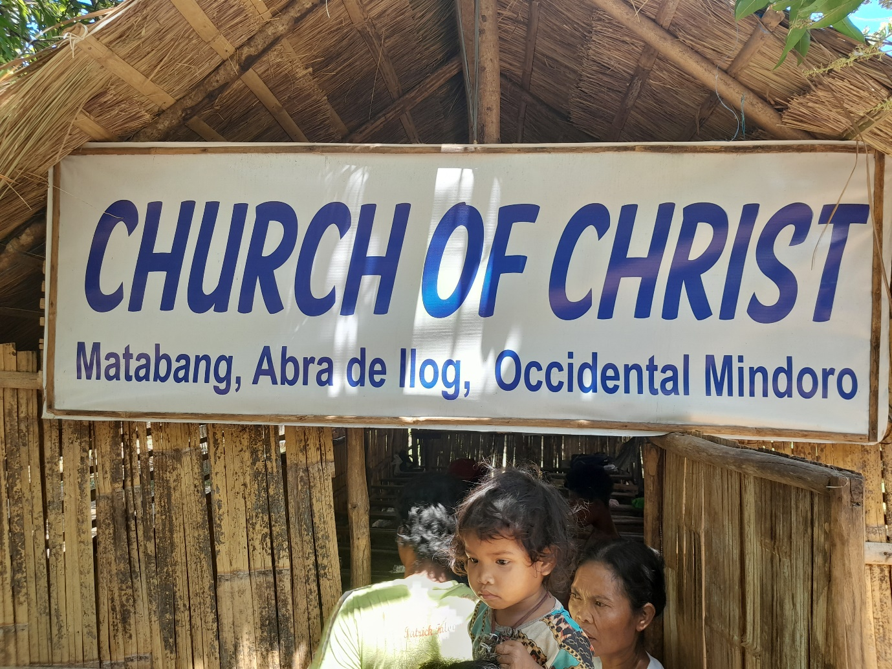

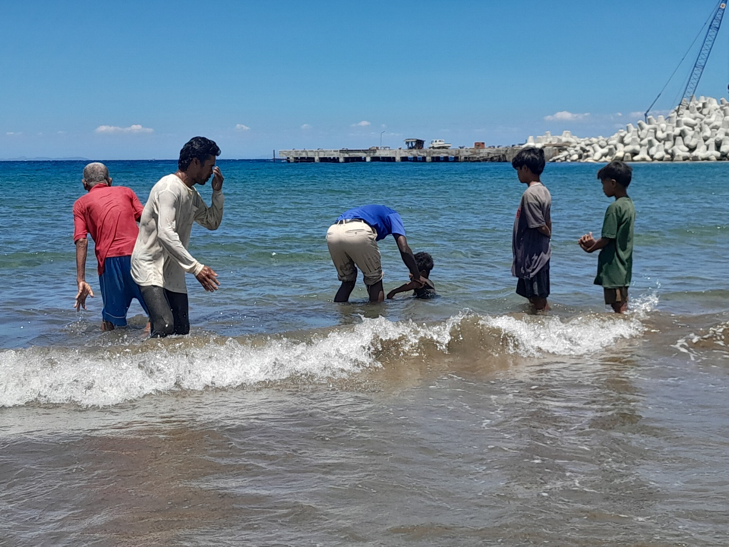
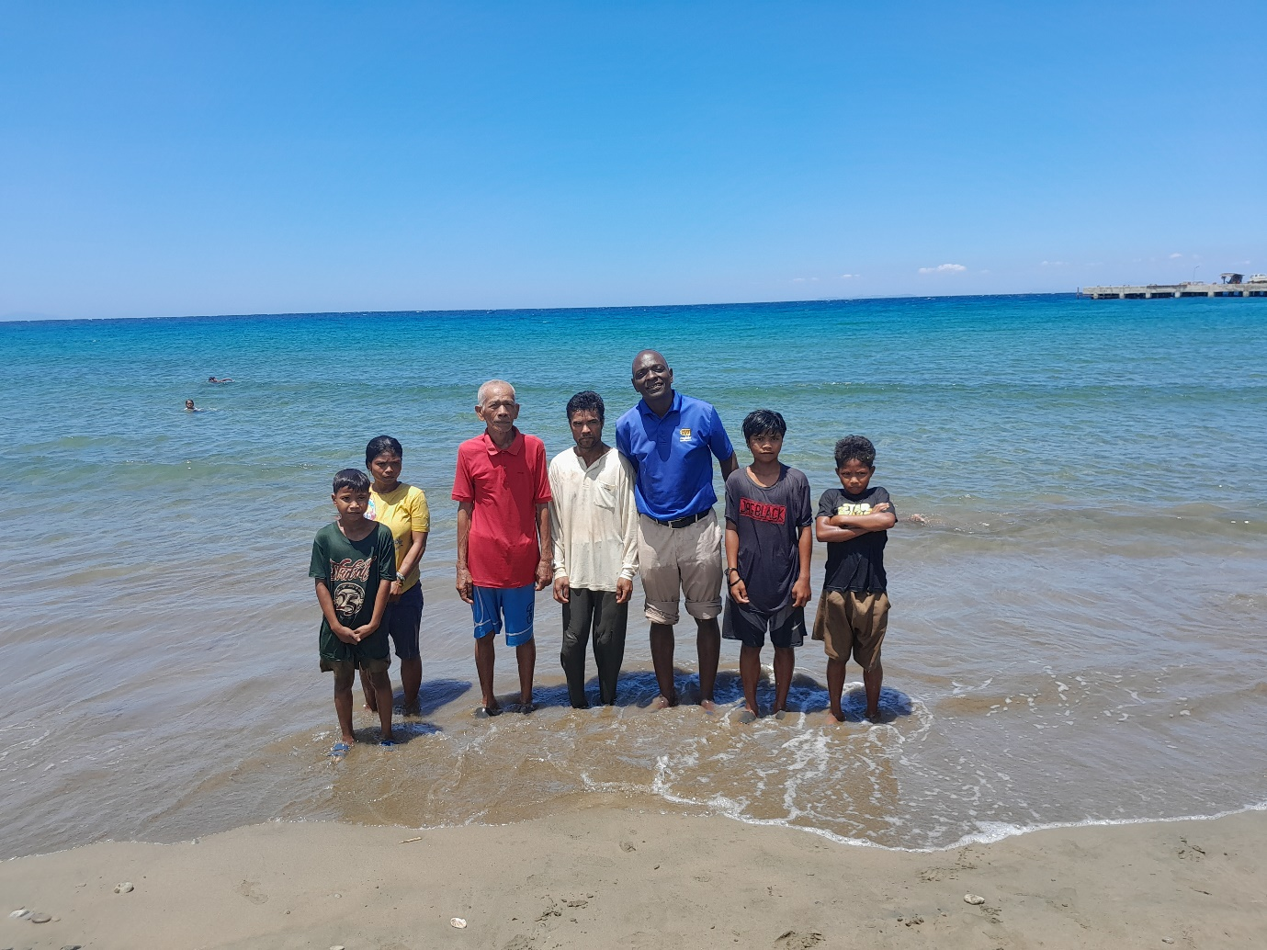
After lunch, we proceeded to Tuay Church meeting place where I taught an hour long lesson on prayer.
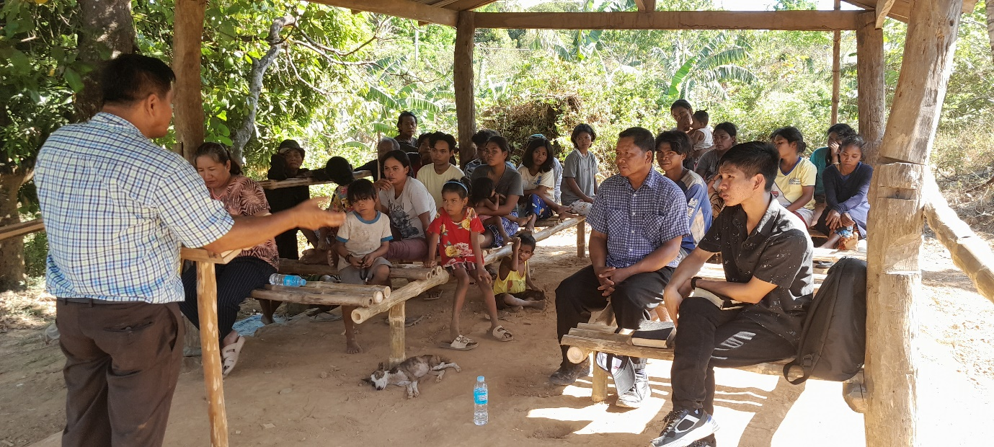
At the end of the class four youngsters stood up to repent. We went down to a river about two kilometres away to baptise them. Again, I baptised them.
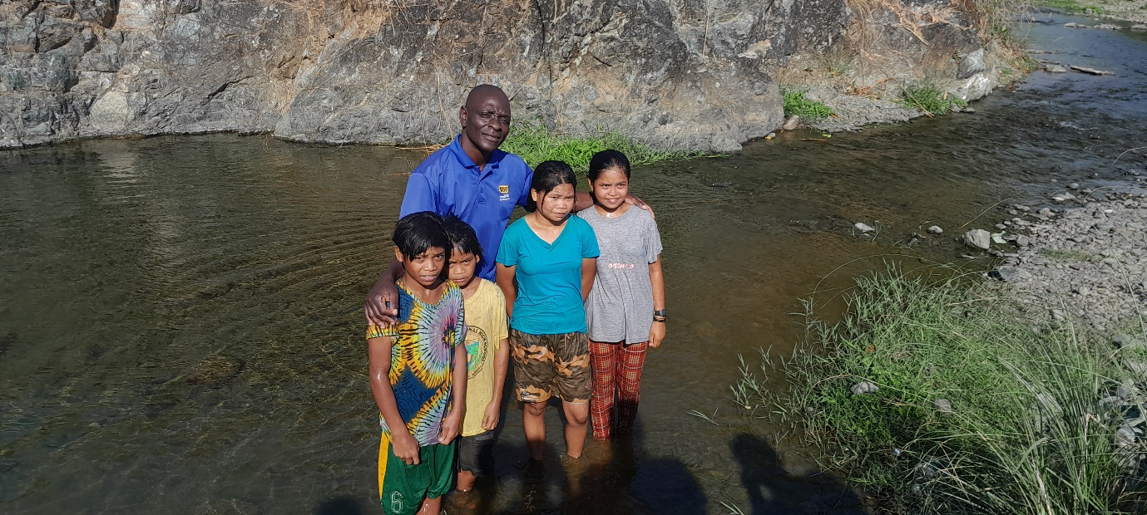

FRIDAY 25 MARCH 2023
We drove for about 40 kilometres from the hotel we were staying in to a town called Santa Cruz. Just in the outskirts of this town is a congregation called Langa. Rodelio Baagin the man who invited me to the Philippines is a former preacher in the so-called Pentecostal Churches. He became a member of the Lord’s church in 1995. From that time, he established these congregations I visited. The earliest congregation to be established and is now over 25 years is Langa. I taught from PowerPoint a lesson titled Law of Moses versus the gospel of Christ. I answered a couple of questions thereafter. An invitation song was sung and two teenagers stood up to repent. They were baptised in our presence.
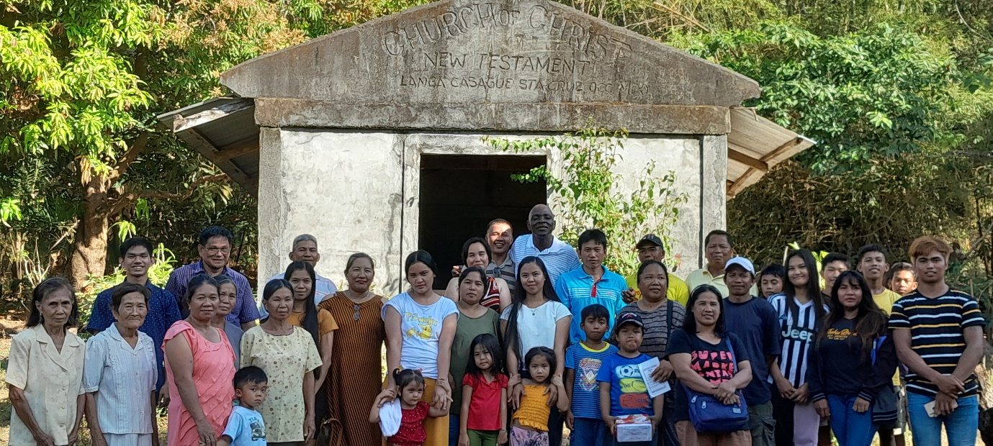
Saturday 26 March
We left in the morning and drove for about 30 kilometres from Santa Cruz where we had slept to a place called Sablayan. The preacher at the local church in the area had requested to have a study at his house. Some members of the congregation came for the study. The preacher is the one sitting on the staircase recording a video my lesson.
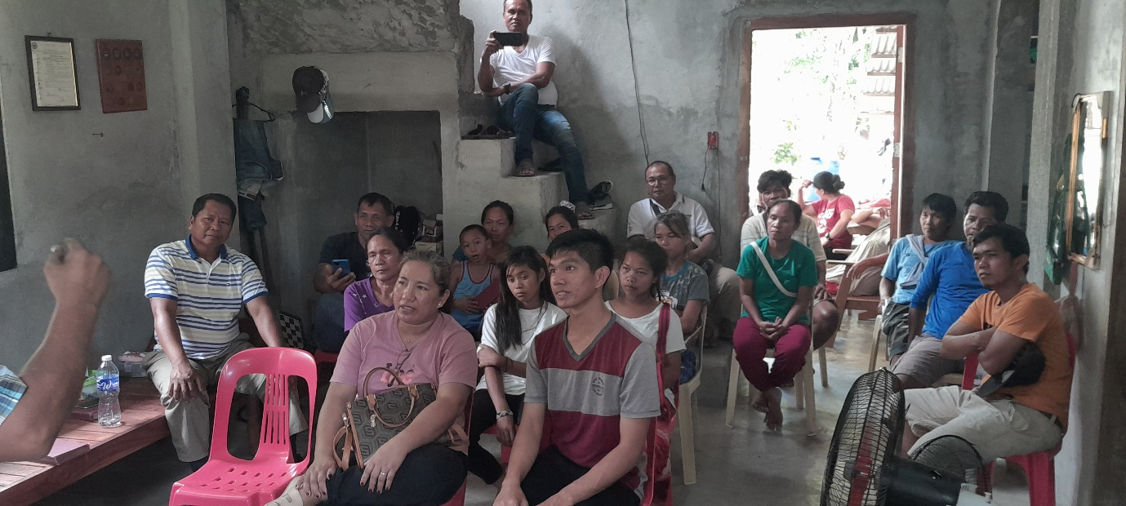
Sunday 27 March
I met with two congregations. First, we met with Almeda Church of Christ. I preached at this congregation from Acts 4:11-12 reminding the brethren what Peter said about salvation which is found in no one else’s name except Jesus and how we need to continue being faithful in his name.
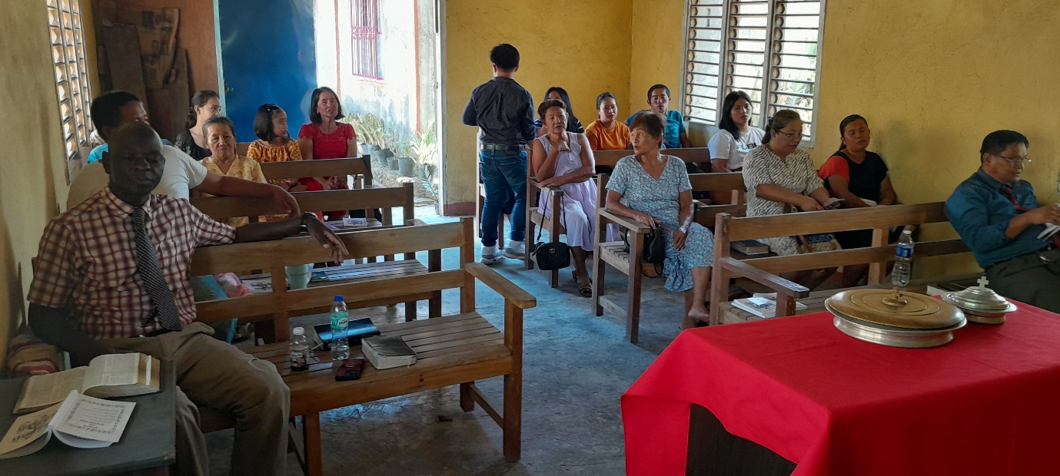
We then relocated to the south and drove for 60 kilometres to another congregation called Alag church of Christ. I taught a lesson from Hebrews 5:11-14 encouraging brethren to grow in the faith.
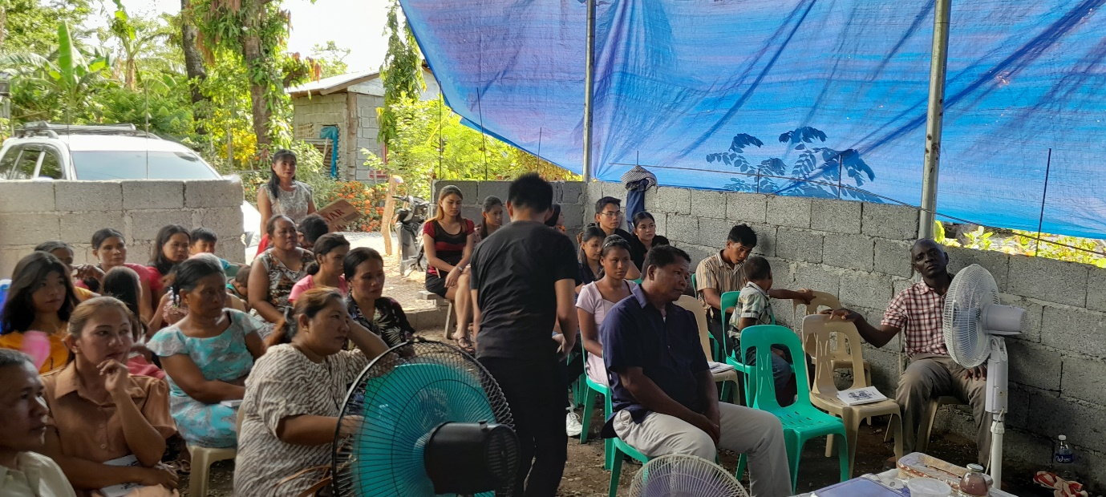
Monday 27 March 2023
I led two bible study sessions at Bagong Silang church building. From 9am to 1pm, I studied with them from PowerPoint a lesson titled “I will build my Church”. There were visitors that had been invited. So, I helped them to see what Jesus meant by that statement and his church which eventually begun on the day of Pentecost. One woman present was a member of Seventh Day Adventist. She raised a few good questions from my presentation which I patiently answered. Eventually she and a thirteen-year-old young man repented and requested to be baptised. We had an afternoon session where I taught from 1 Peter 5:8-9. I encouraged the new converts and the old brethren to be wary of Satan. After the class, we went to a nearby river and baptised the two.
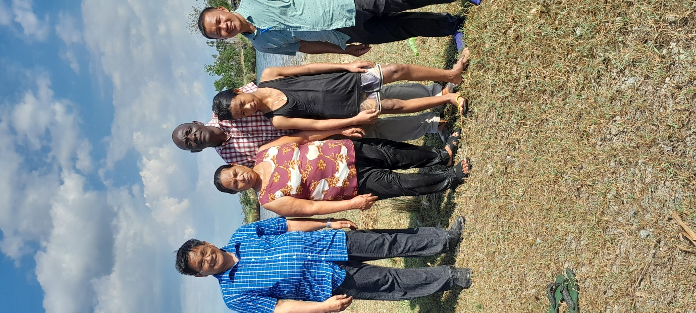

After the baptism of the two, we drove for 80 kilometres to Abra De Ilog port. We were now relocating from the province of Occidental Mindoro to the province of La Union. Originally Rodelio Baagin my host comes from Mindoro but has been living in La Union for the past eight years. In the next morning we would catch the first ferry ship that would take us to Batangas. In the morning of Tuesday, we found the ferry and sailed from 0730 and arrived at Batangas at 0930. We then drove for nearly 400 kilometres via Manila the capital to La Union. In La Union Rodelio has established four congregations. Wednesday was a rest day.
Thursday 30 March 2023
From 9am to 12pm I led a study at Cataguintingan church of Christ from Luke 4:1-13. This church is situated in a town called Rosario about 10 kilometres from Rodelio’s house where we are staying. I encouraged brethren to over rely on the Word of God when defending their faith taking a leaf from Jesus’ answer to Satan in verse 4, “It is written!”.
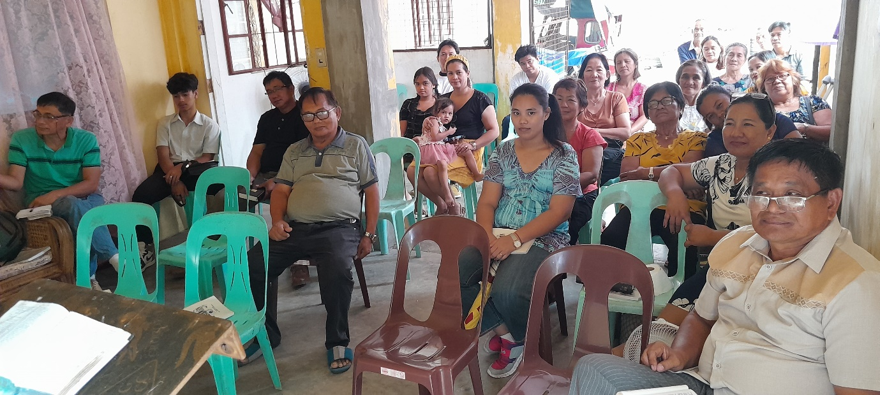

From 2pm to 4pm, I led a study at Labayug Church of Christ 30 kilometres away from Rosario. It is situated in Pangashinan province. I studied with them from Luke 17:1-5 about forgiveness. After the study, I attended to a few questions some connected to the lesson and others general Bible questions. You will notice that some faces that appear in the first picture will appear again in the next picture. Four were my travelling team of Rodelio (in glasses and cream shirt far right) and his wife sitting next to him, another lady and myself. Also, other few people wanted to hear my next lesson at Labayug and they used their own tri circles to follow us.
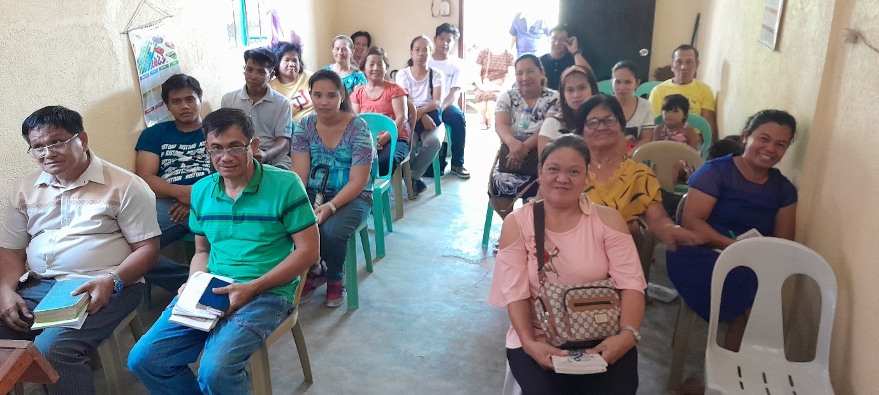
Friday 31 March 2023
My last day of teaching in Philippine. From 2 to 4pm I taught at Pinmilapil Church building. My lesson was from Powerpoint on the outskirts of the town of Rosario. My lesson was titled God’s authority. After the study, and after an invitation song was sung, four people repented and they were baptised.

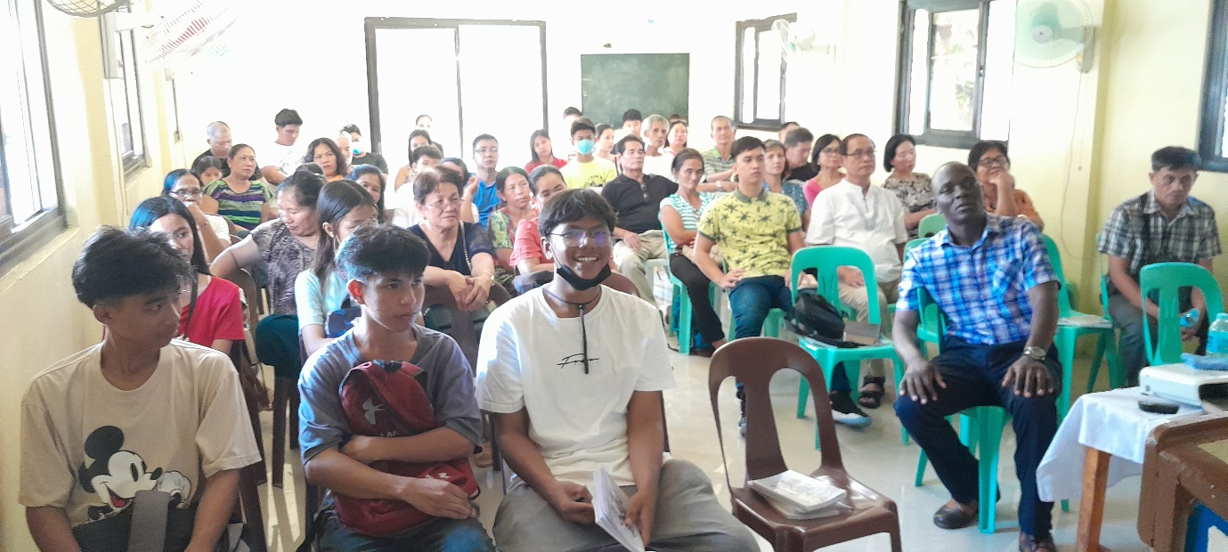
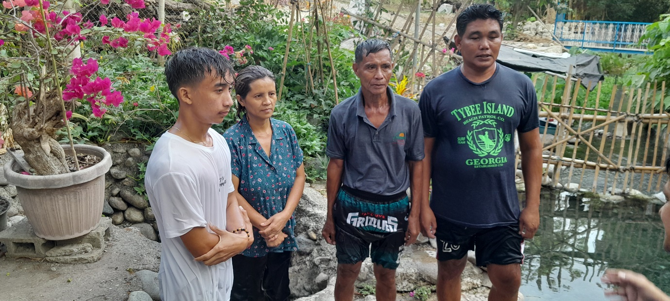

From 6 to 8pm I taught from Powerpoint at San Luis from Luke 17:32, “remember Lot’s wife”. Total baptisms recorded during these classes was 17 people. We pray that they may grow in the faith and become good examples in the Lord’s kingdom.
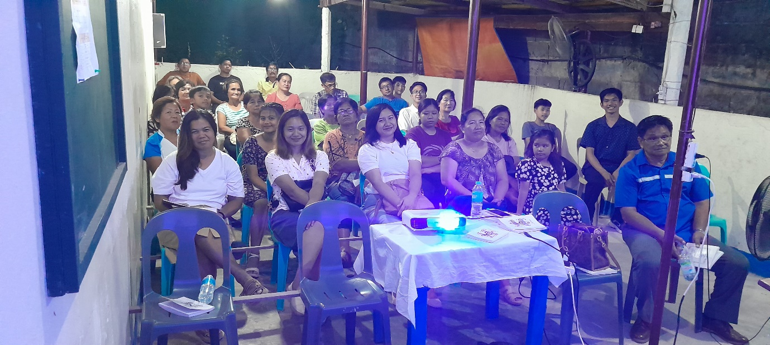

Conclusion
This was a rare opportunity God presented to me in my preaching life so far. It was very important to give me some experience of preaching to the people of different culture altogether in a completely different setting. This was a treasure. It was absolutely humbling when brethren wherever I went received me with gladness. The ten congregations I visited had not been visited by any foreign preacher for over ten years. Four of these congregations are way less than ten years. They were so excited to have me in their presence. This was a humbling experience to me. The last foreign preacher to visit them is an American preacher called Jim McDonald from Texas. Rodelio told me that this preacher is now old and is not able to visit again. The preachers who have been visiting this country in the recent past include Bob Buchanon and Ron Halbrook but they are already occupied with other regions of this big country.
I met a number of men that work with Rodelio. They are primarily from the poorest regions of the country. They all were happy if I could come back and teach the 17 Bible periods programme I have been running in Zimbabwe since 2017. Many of them have denominational backgrounds and still want to be taught the true gospel. A few of them have only studied the three dispensations, (Adamic, Mosaic and Christ). I have always felt that the three are good but they do not comprehensively capture the entire Bible hence my introduction of the seventeen. Without any doubt, the men I have studied with in Zimbabwe are at another level in terms of their Bible knowledge. I said to them everything depends on the affordability and availability of funds. I would be the first to warm up to this request, but everything will be hinged on whether I am able to mobilise enough resources for the programme. I am always ready to teach wherever and whenever it is possible. Six of the congregations visited are in the poor rural areas of Occidental Mindoro a region that is very prone to the yearly typhoons. three of the congregations are in the modest and small towns of Pugo and Rosario while one is in a poor community of Labayug. Whether rich or poor, these brethren are wonderful and amazing. Their hospitality is exceptional.
This trip my ticket which cost $1108 was purchased with funds I was given by two congregations in Durban of South Africa namely Phoenix and Silver Glen. For my other expenses (fuel, food, accommodation etc), Paddy and Sandi Kendall Ball sourced $1600 for me and the funds were just enough for this trip. We provisionally put late January to early February 2024 as the dates for my coming back depending on the will of God and the availability of funds. I head back home Sunday 2 April arriving in the evening of Monday 3 April.
Thank you for your financial support. Well appreciated. Greet all brethren for us.
Your brother
Professor

