Puerto Rico Work Report (April-May 2022)
Caleb Westbrook – HC 2 Box 47421, Sabana Hoyos, PR 00688
713-304-9770/ westbrookcaleb@gmail.com
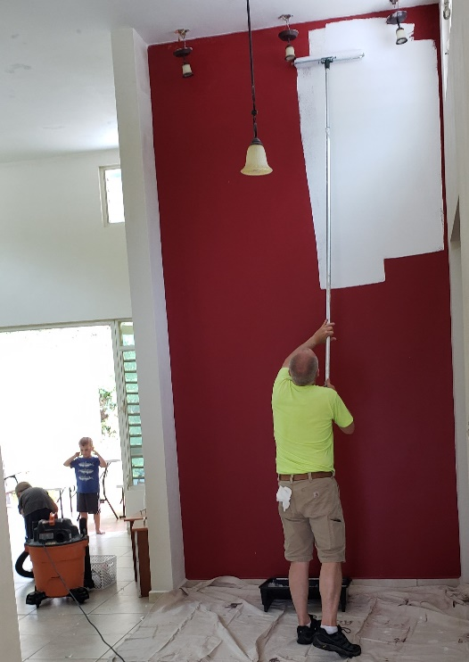
Greetings Brethren of our King,

The past month has been a whirlwind for my family and me. In the middle of April, we closed on our new house in the neighborhood of Miraflores in the county of Arecibo, PR. I foolishly thought that this move would be a breeze compared to our move nearly 5 years ago down here to Puerto Rico from Texas since we were only moving an hour away. I quickly realized that the distance is not what makes a move complicated, but rather the amount of preparation needed to make ready the house one is moving into. After closing on the house in Miraflores we quickly went to work on remodeling, cleaning, and painting. My parents, Rick & Barb Westbrook, along with my younger sister Becca, came to help us with the remodeling and moving work. They stayed for about 10 days and we are very grateful for their help. Kaitlin and I have been working tirelessly for three weeks straight. It has been a very challenging experience and transition for us, but we are excited about the new opportunities and work that we will be able to do for the Kingdom in this area. We still have some more details to finish up on the new house, but our move is mostly complete. We will have a few more projects to complete on the old house in San Sebastian in order to get it ready to sell. We are especially thankful to Eric Huggins and Carlos & Ramona Moscoso for their vital help through our move. Above all, we are grateful to God for the open doors and the safety He has provided us through this change in our lives.

Work in Arecibo
Despite the work with the move, I have had opportunities in the work here. In the heat of the move, I had to postpone a few of my studies, but there were a few that I made exceptions to continue despite the hectic schedule. Brother Edwin and I kept up our studies with Ramon and Maribel. This young couple has faced significant challenges in their transition to married life. Edwin and I have led studies on marital counseling and have tried to connect them with other Christians in the area. They are at a point of significant crossroads regarding the direction that their marriage will head. Sadly, here in Arecibo for years, there has not been much teaching on marriage, but we are slowly trying to change that for the better. Ramon and I have had several conversations and I am hoping that he will soon start up a personal study with Edwin and me.

Unfortunately, the studies that Edwin and I were having with Yadimar and her friends have been put on hold for a bit, but we are hoping to renew them very soon. This past month there was a significant event at Arecibo that raised some questions about the use of the collection. Kaitlin and I have been very open and clear about our beliefs, and we are slowly trying to help teach the principles of God’s truth on this matter to the Puerto Rican brethren who simply have never heard these issues discussed. Kaitlin and I took a stand at the event, and it caused some discussion among brethren in Arecibo. Thanks be to God our response opened up a tremendous opportunity to study the issue of the collection in greater depth with a few of the brethren there. Even though this topic is not something that we are ready to present to the entire group, we are making significant headway with the brothers that we are studying with directly on this topic. Personally, I am learning a lot in regard to improving my communication and clarity on this topic. Recently I had a 4-hour study with a brother in Arecibo on this matter and he told me, “Caleb, this is new to me so it will take me a while to understand, but what you are saying makes sense.” These types of studies and changes take a long time to develop and show fruit. It is so easy for all of us to be locked into our traditions and we all need God’s grace and truth to open our eyes to His perfect pattern.

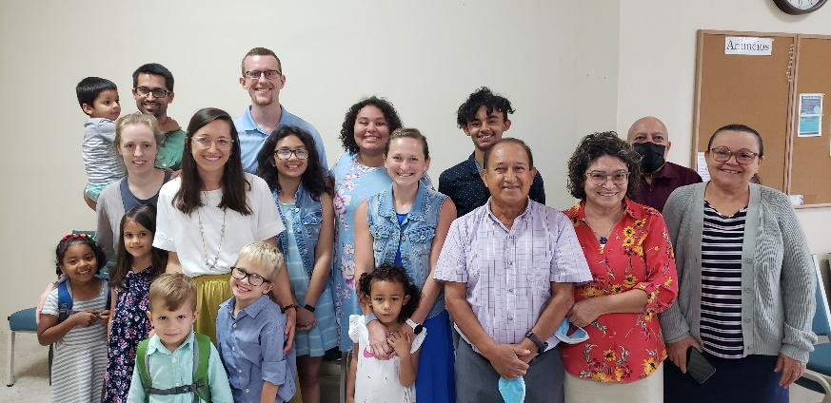
I had an opportunity to preach at Arecibo last month and I presented a lesson entitled, “Sitting at the Gates of Sodom,” where I explained the importance of godly judgments and the danger of evil influences in the story of Lot. The brethren at Arecibo have also put me to work leading songs there and there have been some challenges. Even though the church at Arecibo basically uses the same book as San Sebastian the repertoires of songs are very different. Kaitlin and I are hoping to host some singings soon at our house to help teach new songs and learn some of the songs we don’t know well that the brethren in Arecibo use.

Work in San Sebastian
Leading up to our move we had some wonderful opportunities in San Sebastian. My distant cousin Bradley Lankford and his family came to visit us. The Lankford family was down in Puerto Rico for a family vacation, but they spent a lot of time visiting with us and learning more about the Lord’s work in PR as well as the culture and language. We were really encouraged to spend time with the Lankford’s and we are thankful for the work they are doing in the Kingdom.

Over the past month, I have continued to preach weekly in San Sebastian. Eric is continuing his class on the book of 2 Samuel, and it is going well. Prior to the move, Kaitlin had several studies with 2 Mormon girls that came to visit our house. I was able to sit in on two of the studies. Kaitlin spent a lot of time studying, reading, and trying to reason with the Mormon girls. Sadly, they were too steeped in their indoctrination and were not going to be spending much more time in the San Sebastian area. Nevertheless, we presented the gospel and who knows what might happen with that seed. Also, it was a great experience for Kaitlin to learn more firsthand about Mormon doctrine.

There are many plans that we are working toward for the future if God permits. At the end of May, we are hoping to have a gospel meeting with Brigham Eubanks from Atlanta, GA. There are also a host of plans for studies and activities that are working toward here in Arecibo. We are so grateful for your support, prayers, and fellowship in our work. If you have any questions, please feel free to contact me at any time. Please note that we now have a new address that is noted at the top of this report. Thank you brethren, and God bless!

Grace be with you always,
Caleb B. Westbrook

