Puerto Rico Work Report (February-mid March 2023)
Caleb Westbrook – HC 2 Box 47421, Sabana Hoyos, PR 00688
713-304-9770/ westbrookcaleb@gmail.com

Greetings Brethren in Jesus our King,
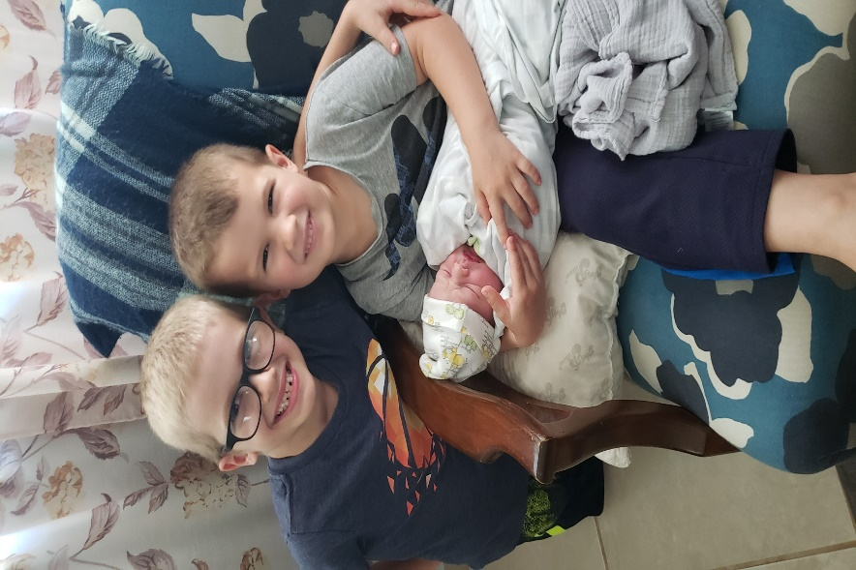
God has been abundantly merciful to us this past month. We have had so many incredible highs and lows. We give God all our thanks and praise for helping us through the challenges. First, we rejoice and are so pleased to announce the arrival of our new son, Nehemiah Boyd Westbrook. Kaitlin and Nehemiah are both doing well, thanks be to God. Kaitlin had a challenging pregnancy, but her labor and delivery went very smoothly, thanks be to our Lord! The name Nehemiah means “Jehovah comforts,” and we have certainly been comforted by this blessing of our son. His shortened nickname will be “Nemi”. Our other two sons, Abraham and Enoch, are thrilled with the arrival of their new brother and Kaitlin’s mother and grandmother have come to stay with us to help out with things here. We are now entering the challenging time period of having a newborn where sleep is a scarcity and there are always a lot more things to balance. Lordwilling, my parents will be visiting in April to help us out as well. So at least for the first month and a half, we will have plenty of help. The brethren here have been very supportive and so excited about Nehemiah’s (Nehemias in Spanish) arrival. We give thanks to God for this tremendous blessing and His wondrous protection through all of this wonderful change in our lives. We are grateful for the thoughts and prayers of so many brothers and sisters during this time.
Abe, Enoch, & Nehemiah

Prayer Request
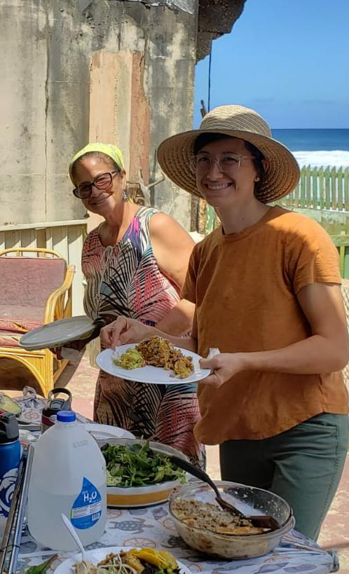
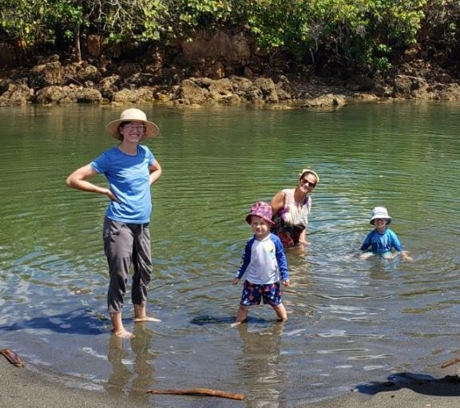
Although we have been overwhelmed with joy and comfort with our new son, this past month brought some very difficult emotional challenges for us. For nearly the past 2.5 years we have grown very close with sister Rosie Mostache from the church in Arecibo. Rosie has been a great friend to both Kaitlin and me. Rosie is always a joy to be around, and she has always gone out of her way to include us in activities, like teaching our boys about sea turtles, inviting us to beach clean-ups, and helping us with get-togethers at our house. Rosie would often help Kaitlin with projects, and she would visit us to help me with various agricultural jobs around our house. In terms of closeness and affection, she was the closest Puerto Rican sister that we have had here in PR. Towards the middle of February she graciously came over to our house to watch Abe and Enoch while Kaitlin went to grab dinner together and when we came back she told us that she needed to have an operation. We prayed with her and talked with her for a long time. Rosie has always had a lot of faith in God. The following week she had the operation and things appeared to have gone well, but her hemoglobin levels were low. Several days later she called Kaitlin and me and while we were talking with her she said that she was having trouble with her vision, but she acted like it wasn’t a major problem. Sadly within a few hours after our conversation with Rosie, her husband took her to a hospital in San Juan and on the way Rosie lost the ability to talk. Upon arriving at the hospital, the doctors put her into a medically induced coma. They found out that Rosie had suffered 4 consecutive strokes and also had some type of pulmonary rupture. For the past few weeks Rosie has been in a coma and the doctors were preparing to transition her to her house and allow Hospice to oversee the final stage of care. But this past Sunday Rosie opened her eyes. Sadly, she is still not very responsive, and the doctors do not know if a recovery is possible our not. Our hearts break for our dear sister and we have cried out to God with many tears on behalf of our dear sister Rosie. We hope and pray that she will be able to recover. Please pray for her and for the brethren here as we still are going through the struggle of waiting on God for His decision.
Rosie and Kaitlin
Rosie with Kaitlin and the boys at the beach

Bible Studies
Even though things have been very busy with both Kaitlin’s pregnancy and sister Rosie’s condition, I have been blessed with the opportunity to have a lot of bible studies this past month. Edwin and I have continued to study together, and I am still so encouraged by his steady and consistent growth. We also had the opportunity to study more with Edwin’s brother Tony. Tony preaches in Aguadilla (on the northwest corner of PR about 45 minutes from where I live) and he has been enjoying the deeper dives on biblical topics with Edwin and me. Toward the beginning of this year, there were more people from a pro-woman preacher congregation that began to attend in Aguadilla, so Tony was studying and teaching a lot on 1 Timothy 2 and 1 Corinthians 11-14. Sadly, some people began to malign Tony and one brother even claimed that Tony was teaching “the doctrine of the Antis.” Unfortunately, some brethren here in Puerto Rico still use the term “anti” to describe non-institutionalism or any position that they don’t understand or practice. After being called an anti, Tony contacted me for a study and he said, “Now I know how you feel Caleb. These brethren do not want to actually look at what the text says, they just want to find an excuse to justify their current practice. It is not right to call a brother an anti.” Tony knew that some brethren in the past had called me “anti” and I am glad to see that Tony is now fully seeing the truth: that I am not an “anti” but I just simply want to invite people back to the biblical pattern. Tony is doing well, and I am thankful for the opportunities that God is bringing through both Tony and Edwin.

Additionally, God has opened an opportunity to study with a young man named John who lives in Arecibo. John is the boyfriend of Genesis (a young lady who has been visiting the church in Arecibo for a few months). Even though it has been difficult to schedule a study with John, we finally had the opportunity to talk. I gifted him a bible and we talked about the existence of God and the purpose of life. John was very open and honest in his conversation with me, and I hope that he will continue to study. Kaitlin and I are also trying to encourage Genesis and her sister Victoria to study with us.

Each week on Fridays I have been teaching a class on “An Overview of the Old Testament.” We have had good participation and our recorded videos have been viewed and shared with many across Puerto Rico. I have also continued studies on the book of Genesis with Felix and Merri from San Sebastian each week. We are continuing in our studies in the book of Matthew in San Sebastian and I have been presenting lessons on Christian dedication for the recent sermon topics. Kaitlin has continued to help the ladies of Arecibo with the weekly ladies’ bible studies on Tuesdays. I have also continued in my constant effort of publishing articles for our weekly bulletin that we share in Arecibo and in San Sebastian. I praise God that I also have been given an opportunity to preach and teach more in Arecibo. In this next month, I have been asked to teach bible class on Sunday mornings, which I have never done yet in Arecibo. I am hoping that this will be a positive step in the direction of allowing me to teach a series. Sadly, bible classes in Puerto Rico are very unstructured and I am hoping to have an opportunity to present a more organized study here in Arecibo.

Toward the beginning of February Kaitlin and I had the opportunity to have a long-awaited study with 3 couples from Arecibo on the topic of marriage and divorce. The study lasted about 4 hours and was a great introduction to the topic. The topic of marriage and divorce has been a sore issue with these brethren since the events of July 2022 when they were upset with my teaching on the necessity of repentance for Christians who had entered into an adulterous marriage prior to becoming a Christian. While this study in February did not fully resolve any issues, it did open a lot of opportunities for these brethren to calmly listen to our side. The study was very amiable, and I think there is a lot more consideration and contemplation that they are showing to our position now. We will continue to sow the good seed of truth and pray that God will continue to give us open doors and that He will have patience with us all as we try to teach and apply His truth! The study went well for everyone and Lordwilling, I think we will be having more similar studies in the future.

There is so much work to do and we give thanks to God for your continued support and fellowship in our work. Without your help we would not be able to do the good work that we are doing here for the Kingdom. We are always looking for more workers and if you know anyone who might be interested in Spanish work or work here in Puerto Rico, please let us know. Thank you for your prayers on our behalf. If you have any questions about our work here please feel free to contact me anytime. May our great and marvelous God who comforts always bless and keep you in His wondrous and loving care!

Grace be with you,

Caleb B. Westbrook

