Puerto Rico Work Report (May 2023)
Caleb Westbrook – HC 2 Box 47421, Sabana Hoyos, PR 00688
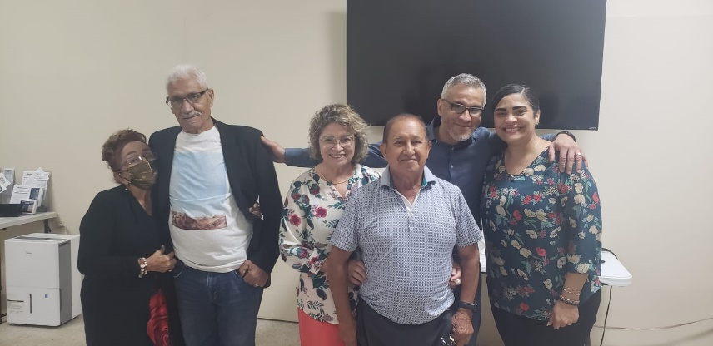
713-304-9770/ westbrookcaleb@gmail.com

Greetings Hermanos en Cristo Jesús,

Please share our warmest greetings with the saints where you attend. We hope and pray that all is going well for you all and that the Lord’s work is abounding where you labor. Thanks be to God we have had a very productive and uplifting month of work in May. Our family is doing well, and baby Nehemiah is growing rapidly. Kaitlin and I are both tired and sleep deprived, but that is part of the blessing of having a newborn. Kaitlin has been doing a wonderful job managing the boys and all has been going well as we have transitioned into a very hot summer here in Puerto Rico. We are excited to share with you some of the opportunities and blessings that God has given us in May.
Tuto and Jahaira visiting San Seb

Arecibo Work
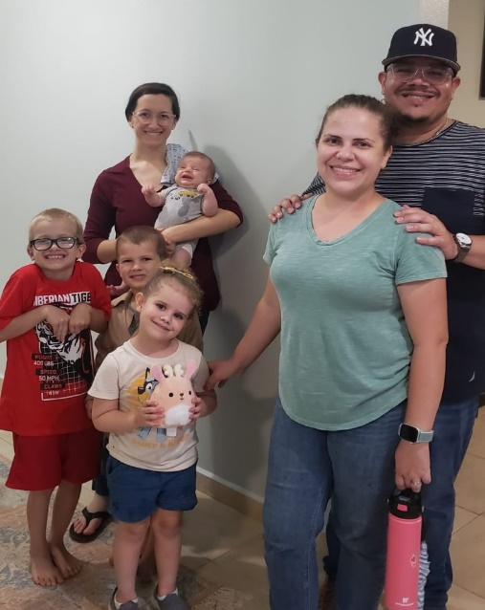
The work in Arecibo has been going well and I have been given many new opportunities for making connections and teaching. I have been teaching the Sunday morning Bible study at Arecibo and we have been discussing the topic of “How we got the Bible”. I have been presenting evidence on the historical reliability of the biblical texts as well as discussing biblical canon and translation. Apparently, this topic had never been taught or discussed at Arecibo before, so the brethren have had a lot of questions and some of those inquiries have opened more private discussions and studies. I have also continued my preaching rotation at Arecibo and the brethren seem to be receiving the lessons very well. My Friday morning classes on “An Overview of the Old Testament” have been going extremely well. We have had very good participation and the lessons are recorded on my Facebook page “Solo Cristianos” (Only Christians) – facebook.com/SoloUnCristiano. Many of the members around the island have been listening to the lessons and some have remarked that this is the first time they have ever studied the Old Testament. If God permits, I am scheduled to finish the entirety of the Old Testament before the end of the year. Additionally, I have been continuing my work of publishing a bulletin every week for the Christians in PR and I have been very encouraged to see how many people it is reaching and helping to edify. One sister from Arecibo takes copies of the bulletins to her business to share with clients and she also uses the bulletin topics as bible study guides for some of the bible classes for the ladies of the church. Kaitlin has been doing an excellent job of working with the sisters at Arecibo and even with her busy schedule she has continued to help teach classes for the weekly ladies’ bible study.

In May we had the blessing of spending more one-on-one time with some of the members at Arecibo. Our family went to visit sister Violeta who lives close by, and we were able to help her with a home project. Violeta also brought her sister to visit us at our house. It has been a blessing to be able to grow closer to sister Violeta. We also had an opportunity to invite Rene, his wife Yari, and their daughter Alana, over to our house in May. Rene and Yari are Christians and attend the church in Arecibo with us. They both are very talented, and we had the opportunity to spend an entire afternoon with them talking about the history of the church in PR, raising godly children, and evangelistic opportunities. Rene usually teaches the Wednesday night bible study in Arecibo and aside from brother Edwin, I have grown closer to Rene than any other brother in Arecibo. Rene has a good mind and is willing to study things out. There are many things we still must discuss, but there is a lot of progress with him and the other brethren in Arecibo. Even though things have been a bit crazy with the newborn, Kaitlin has done an amazing job at continuing to open our home for hospitality during these busy times. I am thankful for all the work that she does for the benefit of the Kingdom in this area.
The Rosario family’s visit

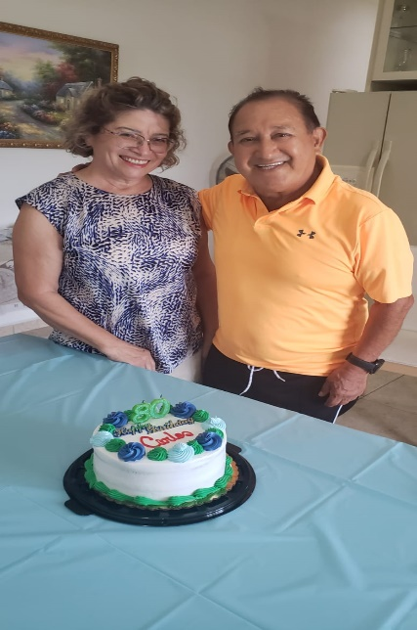
Brother Edwin and I also were able to revisit some contacts and promote more bible studies through May. We had several opportunities to study with Yadimar and visit others in the community. Brother Edwin and I have continued to study together, and Edwin always has excellent questions and provides me with a lot of helpful feedback on my classes, sermons, and writings. Edwin and I have also been working to encourage the brethren in Arecibo to work more on evangelistic efforts. We have been planning some activities that we hope to undertake toward the end of the summer if God wills.

The Work in San Sebastian
Throughout the month of May I had more opportunities to work and help with the brethren in San Sebastian. Brother Felix Cruz had a bit of a health problem, so his son and daughter-in-law came to visit San Seb for about two weeks. It was very encouraging to see Felix’s son, Tuto, and to spend some time with them. Both Tuto and his wife Jahaira are Christians, and they live in north Georgia. It was very helpful to have their participation in bible studies and classes. We were also blessed to receive a visit from brother Luis Cruz, whom I had baptized in Lares, PR about two years ago. Luis was visiting from Florida with his friend Samaria and his brother Jose (who lives in Arecibo). Their visit was short, but we were encouraged to see that Luis seems to be maintaining firm in his faith and is actively trying to invite others to Christ. Brother Carlos Moscoso, who is a faithful member with us at San Seb, turned 80 in May. Carlos still has a lot of energy and he and his wife, Ramona, have been a great help and support to me in the work in San Seb. I pray that God will bless Carlos with many more years of work and service in the Kingdom. Throughout May I was blessed to have some more direct studies and conversations with our perpetual visitor Alfonso. He is showing growth and little by little he seems to be leaving the old systems of denominationalism behind. There is still a lot of work to be done, but even the members at San Seb are seeing his slow, but sure progress.
Carlos’ 80th bday
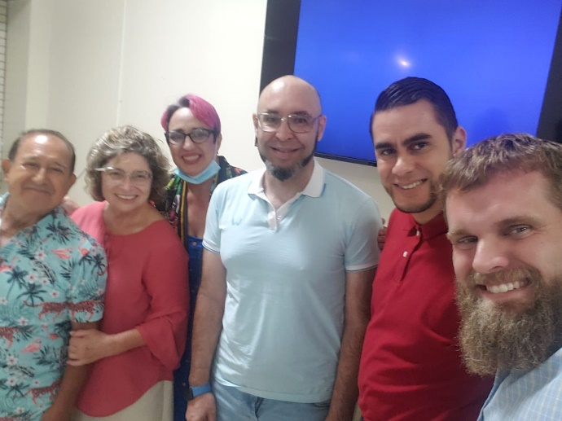
Thank you, brothers and sisters, for your continued support, prayers, and messages on our behalf. We give thanks to our loving Father for the fellowship that we share in Christ Jesus our Lord. We pray that God will continue to give us strength to press on in His work. We also pray that God will send more workers to help us in Puerto Rico. If you know of anyone who might be interested in the work in PR please let us know. May our God of wisdom, peace, and love always bless you and keep you in His blessed care!
Luis’s visit to San Seb
Grace be with you,
Caleb B. Westbrook

